What is Docker?

Docker is a software container platform. It resolves a lot of deployment and run issues by using containers. It provides a standard way to package your application with its dependencies into a container. It mainly solves the problem of an application working in one platform and not on another.

1. **What is a Container?**

A container allows a developer to package an application with all the parts it needs, such as libraries and other dependencies, and ship it all out as one package.

1. **How does flow of control work in Docker?**

A developer creates a Dockerfile, which describes how to create a docker image. The docker image can be used to create docker containers, which are running instances of the image. The docker image can be pushed to Docker Hub and the image can be used by anyone to create runtime instances (containers).

1. **What is the difference between Virtualization and Containerization?**

The Virtualization Stack is as follows –

Host OS

Hypervisor

Guest OS1 Guest OS2 Guest OS3

App1 App2 App3

The Guest and App layer comprise VM1, VM2 and VM3.

There exists a lot of overhead for the 3 different OS’s and space allocation is to be performed.

The Containerization Stack is as follows –

Host OS

VM – VM may be added here. Example – I want to run a Windows application on the Linux OS.

Docker/Container Engine

Lib/bin1 lib/bin2 lib/bin3

App1 App2 App3

The Application and the lib/bin comprise of 3 containers.

There is less overhead as the containers use the Host OS.

1. **What is the architecture of Docker?**

Docker has a client server architecture. Two entities – Docker Client and Docker Server.

Docker Server (Docker Daemon) contains the containers.

The Docker client sends a request to the Docker Server through Command Line Interface or REST API.

Docker Client and Server can be present on the same machine or different machines.

1. **What are the advantages of using Docker?**
2. An application inside a container can run on any system that has docker installed. There is no need to build and configure the application multiple times on different platforms.
3. We test the application inside the container. Thus, the environment where we test will be identical to the one on which the app will run in production.
4. Portable
5. Version Control – Changes can be committed to the Docker image and we can version control them.
6. Every application runs isolated.
7. **What are the basic Docker commands?**

**Basic Docker Info**

docker version – Gives you the client and server versions

docker info – Container Info, Server Details, Driver Information, Plugin Details, etc.

docker --help – Gives you the set of commands that can be used

**Docker Image Commands**

docker images --help

docker login – Used to login to hub.docker.com

docker images – List of images

docker pull <imageName> – Example - docker pull ubuntu

docker images -q – Shows the Image ID

docker images -a – Gives us all the details about the images

docker rmi <imageID> – To remove an image

docker inspect image

**Docker Container Commands**

docker ps – Lists the containers

docker ps -a - Lists all containers regardless of whether they are running or not

docker run <imageName> – If the image is not found, it is downloaded, but no instance is created

Example – docker run -i -t ubuntu bash (it = interactive, tty)

docker start <imageID>

docker stop <imageID>

**Docker System Commands**

docker stats – Memory, CPU usage, etc.

docker system df – Disk Usage

docker system prune – Removing unused data

1. **What are Docker Images?**

Docker images are templates used to create Docker containers. A Container is a running instance of an image. The images are stored in Docker Hub (Registry). An image contains a union of layered file systems stacked on top of each other.

docker run --name MyUbuntu1 -it ubuntu bash

1. **What are Docker Containers?**

Containers are the running instances of images.

docker ps // Shows us the containers that are running

docker ps -a // Shows us all the containers, regardless of running(start)/stop state.

We can use MyUbuntu1(Container Name) OR the Container ID

docker run --name=MyUbuntu1 -it ubuntu // Interactive session of Ubuntu

docker pause MyUbunut1

docker unpause MyUbuntu1

docker start MyUbuntu1

docker stop MyUbuntu1

docker top MyUbuntu1 // Shows the top processes (PID, User, Time, Command)

docker stats MyUbuntu1

docker attach MyUbuntu1

docker kill MyUbuntu1

docker rm MyUbuntu1

docker history ubuntu (Use the ImageName/ID here)

1. **What is Jenkins?**

Jenkins is a continuous integration server. We can create a job. We can check our builds.

docker pull jenkins

To run the Jenkins image – docker run -p 8080:8080 -p 50000:50000 jenkins

This starts a Jenkins server on a docker container.

docker run --name MyJenkins -p 8080:8080 -p 50000:50000 -v /Users/Shravan /Desktop/Jenkins_Home: /var/jenkins_home jenkins

**Kubernetes Course**

* **Why do we need Containers?**

Compatibility/Dependency issues, Long Setup time, Different Dev/Prod/Test environments.

Web Server [Libs, Deps]; Database [Libs, Deps]; Messaging [Libs, Deps]; Orchestration [Libs, D]

Web Server = Container 1, Database = Container 2, Messaging = Container 3…

Docker

OS

Hardware Infrastructure

All that was needed to do was to install Docker on the system regardless of the underlying OS and just use a docker run command. We containerize applications and run each service with its own dependencies in separate containers.

* **What are Containers?**

Containers are completely isolated environments. They can have their own processes and services, networking interfaces and mounts, like VM, BUT they share the same OS Kernel.

* **OS Concepts**

OS consists of two parts – The OS Kernel and the set of Software. Kernel for Ubuntu, Fedora, etc. is the same, i.e. Linux Kernel which interacts with the hardware. The Software on top is what distinguishes these Linux flavors. Example of the different Software may be different UI, Drivers, Compilers, File Managers, Developer Tools, etc.

Example – Suppose we have Docker running on Ubuntu. Docker can run any OS on top of it if they are based on the same Kernel (Linux). Docker can run a container based on Debian, Fedora, etc. A windows container cannot be run on a Linux kernel and can only be run on a Windows server.

* **Containers vs Virtual Machines**

Container (Application, Libs, Deps) -> Docker -> OS -> Hardware Infrastructure

VM (Application, Libs, Deps, OS) -> Hypervisor -> OS -> Hardware Infrastructure

VMs are heavy and have high overhead. However, we can have a Windows VM/Linux VM on the same Hypervisor.

* **Image vs Container**

An image is a template which is used to create one or more containers. Containers are running instances of images that are isolated and have their own environment and set of processes.

The Docker Image consists of the Dockerfile and the .war file.

* **Container Orchestration**

The process of automatically deploying and managing containers is called Container Orchestration. K8s is a container orchestration technology. Docker Swarm and MESOS are also orchestration technologies.

User traffic is balanced across the various containers. When demand increases, we deploy more instances of the application. When we run out of hardware resources, scale the number of underlying nodes up or down.

* **K8s Architecture**

Node (Minions, Worker Nodes) – A node is a machine, physical or virtual on which K8s is installed. A node is a worker machine and is where containers are launched by K8s.

Cluster – A group of nodes grouped together. If one node fails, the application is still accessible via the other nodes. Multiple nodes help share the load as well.

Master – Master is another NODE with K8s installed in it. It manages the orchestration of containers on the worker nodes.

Cluster -> Master, Worker Nodes and Nodes -> Containers

**When Kubernetes is installed, the following Components are installed –**

API Server – Front end for K8s. Users, Management Devices, CLI are used to talk to the K8s cluster.

etcd key store – Key – Value store for managing the clusters. Implements locks within the cluster to ensure no conflict between the masters.

Scheduler – Distributes containers across multiple nodes.

Controllers – Help in orchestration and notice and respond when nodes, containers or end points go down.

Container Runtime – Docker, which is used to run the containers.

Kubelet- Runs on each node in the cluster. Make sure containers run on the nodes as expected.

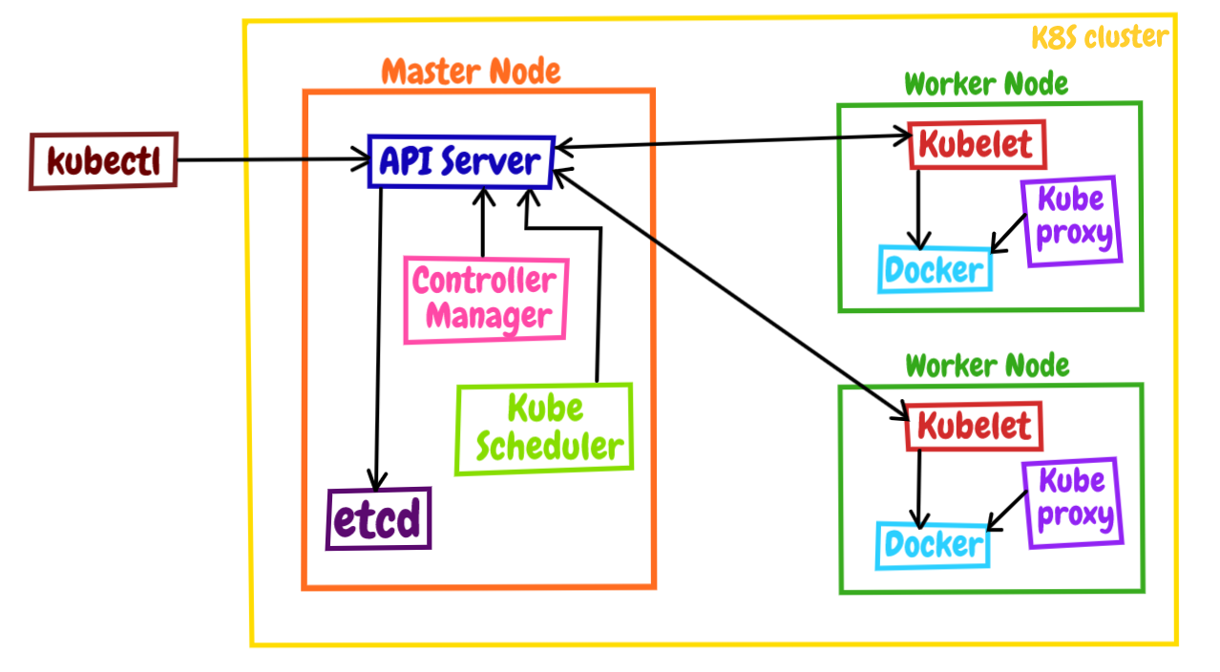

* **Master vs Worker Nodes**

Master Node contains – kube API server, etcd, Controller and the Scheduler

Worker Node contains – Kubelet, Container Runtime (Docker)

Kubelet interacts with kube API server.

* **Kubectl**

Kubectl is used to deploy and manage applications on a K8s cluster.

kubectl run - Is used to deploy an application on the cluster.

kubectl cluster-info – Used to obtain cluster information

kubectl get nodes – Lists all the nodes as part of the cluster.

kubectl get nodes -o wide

* **Minikube**

It bundles all the different components into a single image as a single node K8s cluster.

Kubeadm is used to set up a multi node cluster in a local environment.

We need a hypervisor (Oracle Virtual Box), kubectl and minikube to start working.

* **POD**

A container is encapsulated into a K8s object known as POD. A POD is a single instance of an application.

A POD is the smallest object we can create in K8s.

Consider a single node cluster. Let this node consists of a single POD, and this POD contains a single instance of an application (one container).

If the load increases, we create a new POD within the same node and assign a single instance (container) to it.

If the load further increases, we can deploy a POD on a second node within the same cluster.

Multi Container PODs can be used when we need certain helper containers for our application. These helper containers can be doing jobs such as processing user entered data, processing a file, etc. We need to create a network link between these two containers inside a POD.

Kubectl run nginx -- image nginx = Creates a pod and downloads the image from Docker hub

Kubectl get pods = Shows the pod and the container inside it.

Kubectl describe pods

Kubectl get pods -o wide = Output, Wide gives the IP and Node fields.

Each POD gets its own IP ADDRESS.

Creating PODs using kubectl run can be done in two ways.

1. kubectl run –generator=run-pod/v1 nginx --image=nginx
2. kubectl run nginx --image=nginx --restart=Never

If we run the command without --generator=run-pod/v1 OR --restart=Never, a deployment will be created instead of a version.

Instead, we use kubectl create deployment nginx --image=nginx to create a deployment.

* **YAML Files**

For Key: Value pairs, follow the format Liquid: Water OR Fruit: Apple

For Arrays/Lists, follow the approach

**Fruits** :

- Orange

- Apple

- Banana

For Dictionaries, follow the approach

**Banana** :

Calories : 105

Fat : 0.4 g

Carbs : 25 g

Indentation must work correctly and make sure you space correctly.

Dictionary is an unordered collection, but a list is an ordered collection.

Example of a .yml file

Fruit:

-

Apple:

Color: Red

-

Orange:

Color: Orange

-

Grapes:

Color: Purple

* **PODs with YAML**

K8s uses YAML files as input to create PODs, Replicas, Deployment Services, etc.

A k8s definition file (pod-definition.yml) contains 4 top level fields – apiVersion, kind, metadata and spec.

apiVersion – Version of the K8s API used to create objects. V1 in the current context.

KIND Version

POD v1

Service v1

ReplicaSet apps/v1

Deployment apps/v1

Kind – POD in the current context

Metadata – Data about the object like name, labels, etc.

Metadata:

Name: myapp-pod

Labels:

App: myapp

Under metadata, we can only have the properties K8s expects. Under labels, we can define our

own properties. Example, under labels, we can add type: front-end.

Spec – Spec is a dictionary. We can add a Container property (which is a list).

Example –

Spec:

Containers:

-

Name: nginx-container

Image: nginx

The Full YAML file is as follows (pod-definition.yml)–

**apiVersion** : v1

**kind** : Pod

**metadata** :

name : myapp-pod

labels:

app : myapp

type : front-end

**spec**:

containers:

-

Name: nginx-container

Image: nginx

Env:

* Name: POSTGRES_PASSWORD

Value: password

To create the POD, we perform,

Kubectl create -f pod-definition.yml

* **Replication Controllers**

Controllers are the processes that monitor Kubernetes objects and respond accordingly. The Replication Controller helps us run multiple instances of a single POD in the K8s cluster thus providing high availability.

If we have only a single POD, the replication controller can bring up a new POD if the existing one fails and always ensures the number of PODs specified runs.

Replication Controllers are also needed for load balancing and scaling.

**Replication controller spans across nodes in the cluster.**

* **Replica Sets** – It is new tech, which is replacing Replication Controller, but is the same with minor differences.
* **Creating a Replication Controller (rc-definition.yml)**

rc-definition.yml

**apiVersion** : v1

**kind** : ReplicationController

**metadata** : # Metadata for RC

**name** : myapp-rc

**labels**:

**app** : myapp

**type** : front-end

**spec**:

**template**: # apply the template for the POD here

**metadata** : # Metadata for POD

**name** : myapp-pod

**labels**:

**app** : myapp

**type** : front-end

**spec**:

**containers**:

**- name**: nginx-container

**image**: nginx

**replicas**: 3

pod-definition.yml

**apiVersion** : v1

**kind** : POD

kubectl create -f rc-definition.yml

kubectl get replicationcontroller

kubectl get pods

* **Replica Set (replicasetdefinition.yml)**

The main difference between the Replica Controller and Replica Set is the selector.

**apiVersion** : apps/v1

**kind** : ReplicaSet

**metadata** :

**name** : myapp-replicaset

**labels**:

**app** : myapp

**type** : front-end

**spec**:

**template**: # apply the template for the POD here

**metadata** :

**name** : myapp-pod

**labels**:

**app** : myapp-replicaset

**type** : front-end

**spec**:

**containers**:

**- name**: nginx-container

**image**: nginx

**replicas**: 3

**selector**:

**matchLabels**:

**tier**: front-end

pod-definition.yml

**apiVersion** : v1

**kind** : POD

**metadata** :

**name** : myapp-pod

**labels**:

**tier** : front-end

* **Labels vs Selectors**

Under the pod-definition.yml section, observe –

**metadata** :

**name** : myapp-pod

**labels**:

**tier** : front-end

Under the replicasetdefinition.yml, observe –

**selector**:

**matchLabels**:

**tier**: front-end

**The replica set can manage pods using the label match.**

* **Scaling**

We have 3 replicas currently. If we want to scale to 6, first, update the replicas property to 6.

Next, use the following commands to scale –

Kubectl replace -f replicasetdefinition.yml

OR

Kubectl scale --replicas=6 -f replicasetdefinition.yml

To delete, kubectl delete replicaset myapp-replicaset

* **Deployment**

Deployment is a K8s object that comes higher in the hierarchy. Deployment provides us with the capability to upgrade underlying instances seamlessly using rolling updates, undo changes and pause and resume changes.

deployment-definition.yml

**apiVersion** : apps/v1

**kind** : Deployment

**metadata** :

**name** : myapp-deployment

**labels**:

**app** : myapp

**type** : front-end

**spec**:

**template**: # apply the template for the POD here

**metadata** :

**name** : myapp-pod

**labels**:

**app** : myapp

**type** : front-end

**spec**:

**containers**:

**- name**: nginx-container

**image**: nginx

**replicas**: 3

**selector**:

**matchLabels**:

**type**: front-end

kubectl create -f deployment-definition.yml

kubectl get deployments

kubectl get all

* **Rollbacks and Updates in Deployment**

Rollout 1 – nginx 1.7.0, nginx 1.7.0, nginx 1.7.0 Version 1.7.0

Rollout 2 – nginx 1.7.1, nginx 1.7.1, nginx 1.7.1 Version 1.7.1

Kubectl rollout status deployment/myapp-deployment

// deployment folder has the myapp-deployment

Kubectl rollout history deployment/myapp-deployment

Recreate Deployment Strategy – All the containers are taken down first, and then all of them are brought back up. (Not ideal)

Rolling Update Deployment Strategy – Take down the older version and bring up the newer version one by one. (Default Deployment Strategy)

To apply the deployment, we perform

Kubectl apply -f deployment-definition.yml

OR

Kubectl set image deployment/myapp-deployment nginx = nginx:1.9.1

* **Upgrade Operation**

Consider a deployment object that has a replica set (1) object which contains 5 PODs with one container in each. When an upgrade is performed, the deployment object creates a new replica set (2). It deploys containers into replica set (2) and takes down PODs from replica set (1).

Kubectl get replicasets

This shows two replicasets, (1) with 0 PODs and (2) with 5 PODs

To Rollback,

Kubectl rollout undo deployment/myapp-deployment

Kubectl run – Creates a deployment

Kubectl create -f deployment-definition.yml --record

This allows for the Change-Cause to be noted under the revision section when we check the

rollout history.

* **Networking in K8s**

The Machine has an IP. The node has a different IP Address.

In docker, an IP address is assigned to a container.

In K8s, an IP address is assigned to a POD.

When K8s is configured, we create an internal private network with the address 10.244.0.0 and all the PODs are attached to it.

Cluster Networking –

Consider two nodes, with one POD each.

All containers/PODs can communicate to one another without NAT (Network Address Translation)

All nodes can communicate with all containers without NAT.

We must set up networking on our own and so we use a tool like Flannel for routing.

* **Services**

K8s services enable communication between various components within and outside of the application.

Services helps applications connect with other applications, users, third party data sources, etc.

Services enable loose coupling between micro services in our application.

Suppose we have a node with a POD in it. As a user, we would like to access the IP of the POD via the node.

A service is a K8s object which LISTENS TO A PORT ON THE NODE and forwards that request to the PORT ON THE POD. This is called a NodePort service.

Important Ports –

Target Port – This port can be found on the POD where the request is forwarded to.

Port – The port on the service. The service has its own IP called the Cluster IP.

Node Port – The port on the node. (30,000 – 32767)

Service-definition.yml

**apiVersion**: v1

**kind**: Service

**metadata**:

**name**: myapp-service

**spec**:

**type**: NodePort

**ports**:

**- targetPort**: 80

**port**: 80

**nodePort**: 30008

**selector**:

**app**: myapp

**type**: front-end

To create the service,

Kubectl create -f service-definition.yml

Kubectl get services

Curl <http://192.168.1.2:30008>

* **Services – Cluster IP (Service to Service)**

Front End POD – 1 2 3

Back End Service Layer

Back End POD – 1 2 3

Redis Service Layer

Redis POD - 1 2 3

Service-definition.yml

**apiVersion**: v1

**kind**: Service

**metadata**:

**name**: back-end

**spec**:

**type**: ClusterIP

**ports**:

**- targetPort**: 80

**port**: 80

**nodePort**: 30008

**selector**:

**app**: myapp

**type**: back-end

* **Microservices Architecture**

Example of the Voting App

Voting App UI (Python) -> In Memory DB (Redis) -> Worker (.NET) -> DB (PostGres) -> Result-App

Let us begin an instance of each.

Docker run -d --name=redis redis

Docker run -d --name=db postgres:9.4

Docker run -d --name=vote -p 5000:80 voting-app (UI instance running on 80, publish to 5000 on the host system)

Docker run -d --name=result -p 5001:80 result-app

Docker run -d --name=worker worker

We use links to link two containers together.

Docker run -d --name=vote -p 5000:80 --link redis:redis voting-app

Docker run -d --name=result -p 5001:80 --link db:db result-app

Docker run -d --name=worker --link db:db --link redis:redis worker

* **Namespaces**

A namespace is basically a house where we create our PODs, Deployments, and other objects. We work in the Default namespace. Kube-system is another namespace for its internal purposes for its networking solutions, DNS services, etc. kube-public is another namespace where resources available to all users is created.

Every namespace can have its own set of policies as to what they can do.

To access a resource in another namespace, the format is –

Service Name. Namespace. Service. Domain

Example - db-service.dev.svc.cluster.local

The namespace can be specified in the metadata section of the pod-definition.yml file

Namespace: dev

To create a namespace –

**apiVersion**: v1

**kind**: Namespace

**metadata**:

name: dev

OR

Kubectl create namespace dev

To permanently move to another namespace,

Kubectl config set-context $(kubectl config current-context) --namespace=dev

Kubectl get pods --all-namespaces // All the pods in all of the namespaces

To limit resources, we create a quota

Compute-quota.yml

**apiVersion**: v1

**kind**: ResourceQuota

**metadata**:

name: compute-quota

namespace: dev

**spec**:

hard:

pods: “10”

requests.cpu: “4”

requests.memory: 5Gi

limits.cpu: “10”

limits.memory: 10Gi

--dry-run: By default, as soon as the command is run, the resource will be created. If you simply want to test your command, use the --dry-run=client option. This will not create the resource, instead, tell you whether the resource can be created and if your command is right.

-o yaml: This will output the resource definition in YAML format on the screen.

Use the above two in combination to generate a resource definition file quickly, that you can then modify and create resources as required, instead of creating the files from scratch.

#### Important Pointers

#### POD

**Create an NGINX Pod**

kubectl run nginx --image=nginx

**Generate POD Manifest YAML file (-o yaml). Don't create it(--dry-run)**

kubectl run nginx --image=nginx  --dry-run=client -o yaml

#### Deployment

**Create a deployment**

kubectl create deployment --image=nginx nginx

**Generate Deployment YAML file (-o yaml). Don't create it(--dry-run)**

kubectl create deployment --image=nginx nginx --dry-run=client -o yaml

**IMPORTANT:**

kubectl create deployment does not have a --replicas option. You could first create it and then scale it using the kubectl scale command.

**Save it to a file - (If you need to modify or add some other details)**

kubectl create deployment --image=nginx nginx --dry-run=client -o yaml nginx-deployment.yaml

You can then update the YAML file with the replicas or any other field before creating the deployment.

#### Service

**Create a Service named redis-service of type ClusterIP to expose pod redis on port 6379**

kubectl expose pod redis --port=6379 --name redis-service --dry-run=client -o yaml

(This will automatically use the pod's labels as selectors)

Or

kubectl create service clusterip redis --tcp=6379:6379 --dry-run=client -o yaml  (This will not use the pods labels as selectors, instead it will assume selectors as **app=redis.**[You cannot pass in selectors as an option.](https://github.com/kubernetes/kubernetes/issues/46191)So it does not work very well if your pod has a different label set. So generate the file and modify the selectors before creating the service)

**Create a Service named nginx of type NodePort to expose pod nginx's port 80 on port 30080 on the nodes:**

kubectl expose pod nginx --port=80 --name nginx-service --type=NodePort --dry-run=client -o yaml

(This will automatically use the pod's labels as selectors, [but you cannot specify the node port](https://github.com/kubernetes/kubernetes/issues/25478). You have to generate a definition file and then add the node port in manually before creating the service with the pod.)

Or

kubectl create service nodeport nginx --tcp=80:80 --node-port=30080 --dry-run=client -o yaml

(This will not use the pods labels as selectors)

Both the above commands have their own challenges. While one of it cannot accept a selector the other cannot accept a node port. I would recommend going with the `kubectl expose` command. If you need to specify a node port, generate a definition file using the same command and manually input the nodeport before creating the service.

1. -o jsonOutput a JSON formatted API object.
2. -o namePrint only the resource name and nothing else.
3. -o wideOutput in the plain-text format with any additional information.
4. -o yamlOutput a YAML formatted API object.

* **Commands and Arguments – Docker**

Containers are not meant to run an Operating System. They are used to run an instance of a web server or application server, a database, etc. Containers only live if the process inside it is alive. Container exits if the web server crashes.

CMD in the dockerfile dictates the command that will be used for that image.

We can create our images and specify the CMD.

CMD [“sleep”, “5”] where the first element is the executable.

If we consider the Ubuntu image, the CMD is originally bash. Bash searches for a terminal, finds that there is none, and exits. We can use the base image of ubuntu and change the CMD command and make Ubuntu run permanently in the background.

We can then perform the command,

Docker build -t ubuntu-sleeper

Docker run ubuntu-sleeper

Docker will sleep for 5 seconds and then exit.

ENTRYPOINT [“sleep”]

Docker run ubuntu-sleeper 10

This 10 is passed as input to the ENTRYPOINT parameter and then Ubuntu sleeps for 10s.

For a default value, CMD [“5”] should be specified.

To further override, we perform the command,

Docker run –entrypoint sleep2.0 ubuntu-sleeper 10

* **Commands and Arguments – Kubernetes**

To specify the 10s, we modify the pod-definition.yml as follows in the args section

**apiVersion**: v1

**kind**: Pod

**metadata**:

**name**: ubuntu-sleeper-pod

**spec**:

**containers**:

**- name**: ubuntu-sleeper

**image**: ubuntu-sleeper

**args**: ["10"]

To change the Entrypoint, we use the command parameter and modify the file as follows

**apiVersion**: v1

**kind**: Pod

**metadata**:

**name**: ubuntu-sleeper-pod

**spec**:

**containers**:

**- name**: ubuntu-sleeper

**image**: ubuntu-sleeper

**command**: ["sleep2.0"]

**args**: ["10"]

All the following is based on the Dockerfile –

FROM Ubuntu

ENTRYPOINT [“sleep”] // command overrides this

CMD [“5”] // args overrides this

* **Environment Variables**

We can specify them as follows –

Docker run -e APP_COLOR=pink simple-webapp-color

OR

Under containers,

**Env**:

**- Name**: APP_COLOR

**Value**: Pink

We can also use ConfigMaps or Secrets to set the Env variables.

* **ConfigMaps**

ConfigMaps are used to pass configuration data in the form of key value pairs. When a POD is

created, inject the ConfigMap into the POD so the environment variables are available in the POD.

The two phases involved in configuring ConfigMaps are –

* Create the ConfigMap
* Inject it into the POD

Kubectl create configmap

Kubectl create -f configmap-definition.yml

Kubectl create configmap

<config-name> -- from -literal = <key>=<value>

Example

Kubectl create configmap \

App-config – from -literal=APP_COLOR=blue \

--from -literal=APP_MODE=prod

OR

Kubectl create configmap

<config-name> --from-file=<path-to-file>

Kubectl create configmap

App-config –from-file=app_config.properties

OR

**apiVersion**: v1

**kind**: ConfigMap

**metadata**:

**name**: app-config

**data**:

**APP_COLOR**: blue

**APP_MODE**: prod

Kubectl get configmaps

Kubectl describe configmaps

To inject the configMap into the POD, we define a parameter called envFrom in the pod-definition.yml file.

**containers**:

**envFrom**:

**- configMapRef**:

**name**: app-config

OR

**env**:

**- name**: APP_COLOR

**valueFrom**:

**configMapRef**:

**name**: app-config

**key**: APP_COLOR

OR

**volumes**:

**- name**: app-config-volume

**configMap**:

**name**: app-config

* **Secrets**

**apiVersion: v1**

**kind: Pod**

**metadata:**

**name: envfrom-secret**

**spec:**

**containers:**

**- name: envars-test-container**

**image: nginx**

**envFrom:**

**- secretRef:**

**name: test-secret**

Given a simple Web-Mysql application, we have the host – mysql, database – mysql, user – root, password – pwd. In the configMap, we can place the name of the database. But we cannot place the pwd in a configMap.

Secrets are used to store passwords and keys in an encoded format.

Similar to configMaps, we have to create the Secret and then inject it into the POD.

Kubectl create secret generic

<secret-name> --from-literal=<key>=<value>

Kubectl create secret generic

App-secret –from-literal=DB_HOST=mysql

OR

Kubectl create secret generic app-secret –from-file = app_secret.properties

OR

**apiVersion**: v1

**kind**: Secret

**metadata**:

**name**: app-secret

**data**:

**DB_HOST**: mysql

**DB_USER**: root

**DB_PASSWORD**: pwd

We do not store the values in plaintext. Instead we need to encode these values. This is done as follows –

Echo -n ‘mysql’ | base64

Output – bX1zcWw

Kubectl get secrets

Kubectl describe secrets

To decode, Echo -n ‘bX1zcWw’ | base64 --decode

**containers**:

**passFrom**:

**- secretRef**:

**name**: app-config

A secret is only sent to a node if a pod on that node requires it. Kubelet stores the secret into a tmpfs so that the secret is not written to disk storage. Once the Pod that depends on the secret is deleted, kubelet will delete its local copy of the secret data as well.

* **Docker Security // IMPORTANT**

The host has its own namespace and the container has its own namespace. All processes run by the container are in its own namespace.

ps aux – Lists the processes in the container.

For the Docker host, there are several processes. Docker isolates containers within a system.

Docker host has a root user and several non-root users.

Docker run --user=1000 ubuntu sleep 3600 // User security to ensure user 1000 can run it.

We can also specify this User ID in the dockerfile

FROM ubuntu

USER 1000

Docker build -t my-ubuntu-image

Docker run my-ubuntu-image sleep 3600

Root user within the container vs Root user within the host

To ramp up privileges, we can add the parameter

Docker run --cap-add MAC_ADMIN ubuntu

In K8s, we can set up the settings at a POD level or a Container Level. If set up at a POD level, all the configuration data is applied to all the containers in the POD. If set at both levels, the container settings will override the POD settings.

This is at a POD level

**apiVersion**: v1

**kind**: Pod

**metadata**:

**name**: web-pod

**spec**:

**securityContext**:

**runAsUser**: 1000

**containers**:

**- name**: ubuntu

**image**: ubuntu

**command**: ["sleep", "3600"]

This is at the Container level

**apiVersion**: v1

**kind**: Pod

**metadata**:

**name**: web-pod

**spec**:

**containers**:

**- name**: ubuntu

**image**: ubuntu

**command**: ["sleep", "3600"]

**securityContext**:

**runAsUser**: 1000

**capabilities**:

**add**: ["MAC_ADMIN"]

kubectl exec ubuntu-sleeper – whoami

kubectl exec -it ubuntu-sleeper -- date -s '19 APR 2012 11:14:00'

* **Service Accounts**

There are two types of accounts in K8s. A user and service account.

User Account – Admin, Developer

Service Account – Prometheus, Jenkins

Suppose we have a simple application to display the number of pods on a web page. We need to send a request to the kube-api to get that data. The request needs to be authenticated. For that, we use a service account.

Kubectl create serviceaccount dashboard-sa

Kubectl get serviceaccount

A service account creates a token automatically. The token is used for authentication by the application when interacting with the kube-api. The token is stored as a secret object.

Kubectl describe secret <token-name>

If the application is deployed on the cluster itself, then we can simply mount the service token secret as a volume inside the POD hosting the third party application.

Each namespace has its own default service account. The default service account and its token are automatically mounted to a pod as a volume mount.

Pod-definition.yml

**apiVersion**: v1

**kind**: Pod

**metadata**:

**name**: my-kubernetes-dashboard

**spec**:

**containers**:

**- name**: my-kubernetes-dashboard

**image**: my-kubernetes-dashboard

**serviceAccount**: dashboard-sa

**automountServiceAccountToken**: **false**

/var/run/secrets consists of the service account details within the pod

* **Resource Requirements**

Every POD needs the following resources – CPU, Memory and Disk space.

Minimum amount of resource request for a container – CPU=0.5, Mem=256MiB

Mi = Mebibyte = 2^20

**apiVersion**: v1

**kind**: Pod

**metadata**:

**name**: simple-webapp-color

**spec**:

**containers**:

**- name**: simple-webapp-color

**image**: simple-webapp-color

**ports**:

**- containerPort**: 8080

**resources**:

**requests**:

**memory**: "1Gi"

**cpu**: 1

**limits:**

**memory: "2Gi"**

**cpu: 2**

1 CPU = 1 AWS vCPU = 1 GCP Core = 1 Azure Core

If a POD tries to consume more memory than specified in the limits, then it will be terminated.

The default values must also be set as follows –

**apiVersion**: v1

**kind**: LimitRange

**metadata**:

**name**: mem-limit-range

**spec**:

**limits**:

**- default**:

**memory**: 512Mi

**defaultRequest**:

**memory**: 256Mi

**type**: Container

* **Taints and Tolerations**

Taints and Tolerations are used to set restrictions on what PODs can be scheduled on a node.

Consider a cluster with 3 worker nodes (1, 2, 3). Let there be 4 PODs to be deployed on these nodes (A, B, C, D). The scheduler tries to place these PODs on the worker nodes.

Assumption – We have dedicated resources on Node 1 for a particular use case or application. We first place a taint on Node 1 to make sure all PODs are prevented from being placed on Node 1.

Let us say the taint is called blue.

Unless specified, none of the PODs can tolerate any taint.

If we want POD D to be placed on Node 1, we add a toleration to POD. POD D is now tolerant to the taint blue.

Taint is set on a Node

Tolerations are set on PODs

Kubectl taint nodes node-name key=value:taint-effect

Kubectl taint nodes Node1 app=blue:NoSchedule

Taint-effect can have 3 values – NoSchedule, PreferNoSchedule, NoExecute

**apiVersion**: v1

**kind**: Pod

**metadata**:

**name**: ubuntu-sleeper-pod

**spec**:

**containers**:

**- name**: ubuntu-sleeper

**image**: ubuntu-sleeper

**tolerations**:

**- key**: “app”

**value**: “blue”

**operator**: "Equal"

**effect**: “NoSchedule”

The POD D can go to any of the Nodes 1,2 or 3. The concept is mainly used to just disallow certain PODs from being placed on certain nodes.

PODs cannot be placed on the Master Node because a taint on the Master Node disallows all PODs from being scheduled on it.

Kubectl describe node kubemaster | grep Taint

To untaint

Kubectl taint nodes Node1 app=blue:NoSchedule-

Add a hyphen at the end.

* **Node Selectors**

When we want a particular POD to run only on a particular node.

**apiVersion**: v1

**kind**: Pod

**metadata**:

**name**: ubuntu-sleeper-pod

**spec**:

**containers**:

**- name**: ubuntu-sleeper

**image**: ubuntu-sleeper

**nodeSelector**:

**size**: Large // Identifies the label in the node

To label a node,

Kubectl label node <node-name> <label-key>=<label-value>

Kubectl label node node1 size=Large

In node selector, we cannot provide advanced expressions like NOT SMALL or (LARGE OR MEDIUM)

* **Node Affinity**

Used to ensure PODs run only on specific nodes.

**apiVersion**: v1

**kind**: Pod

**metadata**:

**name**: myapp-pod

**spec**:

**containers**:

**- name**: data-processor

**image**: data-processor

**affinity**:

**nodeAffinity**:

**requiredDuringSchedulingIgnoredDuringExecution**:

**nodeSelectorTerms**:

**- matchExpressions**:

**- key**: size

**operator**: In // NotIn

**values**:

- Large // Small

- Medium

Node Affinity Types

requiredDuringSchedulingIgnoredDuringExecution

preferredDuringSchedulingIgnoredDuringExecution

requiredDuringSchedulingrequiredDuringExecution

During Scheduling – A POD does not exist and is created for the first time. If required, then the POD must follow node affinity rules, else it is not scheduled at all. If preferred, then the POD will try to follow affinity rules, but if not possible, then it will be placed on any available node.

**apiVersion**: apps/v1

**kind**: Deployment

**metadata**:

**name**: red

**spec**:

**selector**:

**matchLabels**:

**name**: red

**replicas**: 3

**template**:

**metadata**:

**name**: red

**labels**:

**name**: red

**spec**:

**containers**:

**- name**: red

**image**: nginx

**affinity**:

**nodeAffinity**:

**requiredDuringSchedulingIgnoredDuringExecution**:

**nodeSelectorTerms**:

**- matchExpressions**:

**- key**: node-role.kubernetes.io/master

**operator**: Exists // Important

* **Multi Container PODs**

The idea of decoupling a large monolithic application into subcomponents known as Microservices enables us to develop and deploy a set of independent, small, and reusable code.

Sometimes, the two services need to work together. A web server and logging service is an example. Multi Container PODs share the same lifecycle, network, and storage volumes.

Three common design patterns when designing multi container PODs

Sidecar, Adapter, and Ambassador Pattern.

Sidecar – Deploying a logging agent alongside a web server to collect logs and forward them to a central log server.

Adapter – Suppose multiple applications generate logs in different formats, then we would like to uniformly process them before sending it to the central log server. Adapter container processes the logs before sending it to the central log server.

Ambassador – The application refers to different databases throughout the course of development. The Ambassador container is used to direct the requests appropriately.

Kubectl exec -it app cat /log/app.log

* **Readiness Probes**

POD Status – Initially it is pending and waits for it to be placed on a Node. Then, once placed on a Node, it moves to a scheduled (ContainerCreating) state where the images need to be downloaded and the containers need to be created. After this, the POD goes into the running state.

POD conditions – PodScheduled, Initialized, ContainersReady, Ready – Each of which have true or false answers.

Usually web servers take a few seconds to be ready. Although it may say that the container is ready to serve, it may not be available to address user traffic now.

K8s assumes that as soon as the container is created, it is ready to serve traffic. The service sends requests to the POD immediately. The service is unaware that the application inside the container may still not be running yet.

For HTTP test - /api/ready to check if it is working

TCP Test – 3306 – Databases

Exec command within a container that exits if the application is ready.

Kubernetes first performs the test on the application before making the state READY. Until then, service does not forward traffic to the POD.

**spec**:

**containers**:

**- name**: app

**image**: kodekloud/event-simulator

**readinessProbe**:

**httpGet**:

**path**: /api/ready

**port**: 8080

**initialDelaySeconds**: 10

**periodSeconds**: 5

**failureThreshold**: 8 // It usually fails after 3 attempts. We can increase the number of attempts

**spec**:

**containers**:

**- name**: app

**image**: kodekloud/event-simulator

**readinessProbe**:

**tcpSocket** :

**port**: 3306

**spec**:

**containers**:

**- name**: app

**image**: kodekloud/event-simulator

**readinessProbe**:

**exec**:

**command**:

- cat

- /app/is-ready

* **Liveness Probes**

Suppose the container is in the Ready state, but due to a bug, the user hitting the container cannot access the container at all, then here, we need to use a liveness probe. A liveness probe tests the application periodically to make sure the container is healthy. If the test fails, the container is destroyed and recreated.

The code defined in the POD definition file is the same as that of readiness probe, except replaced with livenessProbe.

* **Container Logging**

Kubectl logs -f <pod-name> <container-name>

The container name needs to be additionally provided if the POD houses multiple containers.

* **Monitoring and Debugging Applications**

We wish to monitor node and POD statistics, and for this we can use open source solutions like Elastic Stack, Prometheus, Metrics Server, etc. We can have one metrics server per cluster.

Metric Server is an in-memory DB and does not store the data on the disk.

Kubernetes runs an agent on each node called Kubelet which is responsible for receiving instructions from the K8s API Master server and running PODs on the nodes.

Kubelet contains a subcomponent called Container Advisor. It retrieves the performance metrics from PODs and exposes them to the Metric Server through the Kubelet API.

Kubectl top node – CPU and Memory consumption

Kubectl top pod

* **Labels, Selectors and Annotations**

To select a POD, given that we have labeled it, we can perform

Kubectl get pods --selector app=my-app

**metadata**:

**name**: red

**annotations**:

**buildversion**: 1.34

* **Rolling Updates and Rollbacks in Deployments**

Kubectl rollout status deployment-name

Kubectl rollout history deployment-name

Here are some handy examples related to updating a Kubernetes Deployment:

**Creating a deployment, checking the rollout status and history:**

In the example below, we will first **create** a simple deployment and inspect the **rollout status** and the **rollout history**:

master $ kubectl create deployment nginx --image=nginx:1.16

deployment.apps/nginx created

master $ kubectl rollout status deployment nginx

Waiting for deployment "nginx" rollout to finish: 0 of 1 updated replicas are available...

deployment "nginx" successfully rolled out

master $ kubectl rollout history deployment nginx

deployment.extensions/nginx

REVISION CHANGE-CAUSE

1     <none>

**Using the --revision flag:**

Here the revision 1 is the first version where the deployment was created.

You can check the status of each revision individually by using the **--revision flag**:

master $ kubectl rollout history deployment nginx --revision=1

deployment.extensions/nginx with revision #1

Pod Template:

 Labels:    app=nginx    pod-template-hash=6454457cdb

 Containers:  nginx:  Image:   nginx:1.16

  Port:    <none>

  Host Port: <none>

  Environment:    <none>

  Mounts:   <none>

 Volumes:   <none>

master $

**Using the --record flag:**

You would have noticed that the "**change-cause**" field is empty in the rollout history output. We can use the **--record flag** to save the command used to create/update a deployment against the revision number.

master $ kubectl set image deployment nginx nginx=nginx:1.17 --record

deployment.extensions/nginx image updated

master $master $

master $ kubectl rollout history deployment nginx

deployment.extensions/nginx

REVISION CHANGE-CAUSE

1     <none>

2     kubectl set image deployment nginx nginx=nginx:1.17 --record=true

master $

You can now see that the **change-cause** is recorded for the revision 2 of this deployment.

Let us make some more changes. In the example below, we are editing the deployment and changing the image from **nginx:1.17** to **nginx:latest** while making use of the --record flag.

master $ kubectl edit deployments. nginx --record

deployment.extensions/nginx edited

master $ kubectl rollout history deployment nginx

REVISION CHANGE-CAUSE

1     <none>

2     kubectl set image deployment nginx nginx=nginx:1.17 --record=true

3     kubectl edit deployments. nginx --record=true

master $ kubectl rollout history deployment nginx --revision=3

deployment.extensions/nginx with revision #3

Pod Template: Labels:    app=nginx

    pod-template-hash=df6487dc Annotations: kubernetes.io/change-cause: kubectl edit deployments. nginx --record=true

 Containers:

  nginx:

  Image:   nginx:latest

  Port:    <none>

  Host Port: <none>

  Environment:    <none>

  Mounts:   <none>

 Volumes:   <none>

master $

**Undo a change:**

Lets now rollback to the previous revision:

master $ kubectl rollout undo deployment nginx

deployment.extensions/nginx rolled back

master $ kubectl rollout history deployment nginx

deployment.extensions/nginxREVISION CHANGE-CAUSE

1     <none>

3     kubectl edit deployments. nginx --record=true

4     kubectl set image deployment nginx nginx=nginx:1.17 --record=true

master $ kubectl rollout history deployment nginx --revision=4

deployment.extensions/nginx with revision #4Pod Template:

 Labels:    app=nginx    pod-template-hash=b99b98f9

 Annotations: kubernetes.io/change-cause: kubectl set image deployment nginx nginx=nginx:1.17 --record=true

 Containers:

  nginx:

  Image:   nginx:1.17

  Port:    <none>

  Host Port: <none>

  Environment:    <none>

  Mounts:   <none>

 Volumes:   <none>

master $ kubectl describe deployments. nginx | grep -i image:

  Image:    nginx:1.17

master $

With this, we have rolled back to the previous version of the deployment with the **image = nginx:1.17.**

* **Jobs and CronJobs**

K8s wants to make sure your applications live forever. This is why, if we have an ubuntu container performing a command: [‘expr’, ‘3’, ‘+’, ‘2’], then the Ubuntu container is created, result is output, and it exits. This goes on forever as restartPolicy: Always is set to always. The POD keeps recreating the container.

We can switch the restartPolicy to “never” so that once the job is finished, the container is not started/created again by the POD.

ReplicaSet is used to make sure that a set of PODs are always running at a point of time. However a job is used to run a set of PODs to perform a given task to completion.

**apiVersion**: batch/v1

**kind**: Job

**metadata**:

**name**: math-add-job

**spec**:

**completions**: 3

**parallelism**: 3

**template**:

**spec**:

**containers**:

**- name**: math-add

**image**: ubuntu

**command**: ['expr', '2', '+', '3']

**restartPolicy**: Never

kubectl create -f job-definition.yml

kubectl get jobs

To get the output

Kubectl logs <pod-name>

Kubectl delete job <job-name>

Completions parameter gives us the number of PODs that are going to be created. They are created one after the other, once a POD finishes. Parallelism is used to create the PODs at the same time rather than sequentially one after the other.

A cronjob can be used to schedule/do a job periodically.

**apiVersion**: batch/v1beta1

**kind**: CronJob

**metadata**:

**name**: reporting-cron-job

**spec**:

**spec**:

**schedule**: "*/1 * * * *"

**jobTemplate**:

**spec**:

**completions**: 3

**parallelism**: 3

**template**:

**spec**:

**containers**:

**- name**: reporting-tool

**image**: reporting-tool

**restartPolicy**: Never

kubectl create -f cronjob-definition.yml

kubectl get cronjob

* **Networking**

Consider that we are deploying an application for an online store. [www.online-store.com](http://www.online-store.com). We build the application into a docker image and deploy it on the K8s cluster as a POD in a deployment. We then deploy the MySQL database as a POD and create a service of type ClusterIP called mysql-service so that the application can access it.

We then create a service of type NodePort and expose port 38080 for end users to access the application.

A user can now access the application via http://<node-ip>:38080

38080 >> NodePort Service >> Application >> MySQL Service >> MySQL Pod

Whenever traffic increases, we just increase the number of PODs and the service splits traffic among the PODs.

We can configure the DNS server to point to the Node IP. However, the port number still needs to be remembered by the user. We bring in an additional server, a proxy-server that proxies requests on port 80 to port 38080 on your nodes. We then point the DNS to this proxy-server.

Suppose we are on a public cloud environment like GCP. Instead of creating a service of type NodePort, we could send it to a type LoadBalancer. K8s does the work of NodePort, and in addition K8s sends a request to GCP to provision a network LoadBalancer for the service.

GCP deploys a LoadBalancer which has an external IP, and DNS is set to this IP.

Suppose the business grows and we now have [www.online-store.com/clothes](http://www.online-store.com/clothes) and [www.online-store.com/watch](http://www.online-store.com/watch) . We now deploy the video POD as a separate deployment and create a video-service LoadBalancer on port 38282 and this has a new IP.

To address these two LoadBalancers, we need yet another LoadBalancer. We also need to enable SSL for our applications, and we do this via nam by bringing all these LoadBalancers into the cluster.

LB (online-store) >> LB1 (/clothes) >> Clothes Service >> Application (Clothes POD)

>> LB2 (/watch) >> Watch Service >> Application (Video POD)

Ingress helps users access the application using a single externally accessible URL that we can

configure to route to different services within the cluster and implement SSL security as well.

The ingress service is either of type NodePort or LoadBalancer. Load balancing solutions like nginx can be used here. We deploy and then configure them.

The solution we deploy is called an Ingress Controller and the set of rules are called Ingress Resources.

Ingress Resources are created using definition files.

For the nginx-ingress controller, the ConfigMap we use is –

**kind**: ConfigMap

**apiVersion**: v1

**metadata**:

**name**: nginx-configuration

This will contain details about err-log-path, keep-alive and ssl-protocols.

The ingress controller deployment file is as follows –

**apiVersion**: extensions/v1beta1

**kind**: Deployment

**metadata**:

**name**: nginx-ingress-controller

**spec**:

**replicas**: 1

**selector**:

**matchLabels**:

**name**: nginx-ingress

**template**:

**metadata**:

**labels**:

**name**: nginx-ingress

**spec**:

**containers**:

**- name**: nginx-ingress-controller

**image**: quay.io/kubernetes-ingress-controller/nginx-ingress-controller:0.21.0

**args**:

- /nginx-ingress-controller

- --configmap=$(POD_NAMESPACE)/nginx configuration

**env**:

**- name**: POD_NAME

**valueFrom**:

**fieldRef**:

**fieldPath**: metadata.name

**- name**: POD_NAMESPACE

**valueFrom**:

**fieldRef**:

**fieldPath**: metadata.namespace

**ports**:

**- name**: http

**containerPort**: 80

**- name**: https

**containerPort**: 443

We then need to create a service for this deployment –

**apiVersion**: v1

**kind**: Service

**metadata**:

**name**: nginx-ingress

**spec**:

**type**: NodePort

**ports**:

**- port**: 80

**targetPort**: 80

**protocol**: TCP

**name**: http

**- port**: 443

**targetPort**: 443

**protocol**: TCP

**name**: https

**selector**:

**name**: nginx-ingress

We also need to create a ServiceAccount with the correct roles and bindings

**apiVersion**: v1

**kind**: ServiceAccount

**metadata**:

**name**: nginx-ingress-serviceaccount

In conclusion, we inject the ConfigMap and the ServiceAccount into the Ingress Controller and

create a service to expose it.

Ingress Resources – A set of rules configured on the Ingress Controller.

Ingress-clothes.yaml

**apiVersion**: extensions/v1beta1

**kind**: Ingress

**metadata**:

**name**: ingress-clothes

**spec**:

**backend**:

**serviceName**: clothes-service

**servicePort**: 80

kubectl create -f ingress-clothes.yaml

kubectl get ingress

Ingress Resource Rules are based on the URL and the appropriate configurations

Ingress-clothes-watch.yaml

**apiVersion**: extensions/v1beta1

**kind**: Ingress

**metadata**:

**name**: ingress-clothes-watch

**spec**:

**rules**:

**- http**:

**paths**:

**- path**: /clothes

**backend**:

**serviceName**: clothes-service

**servicePort**: 80

**- path**: /watch

**backend**:

**serviceName**: watch-service

**servicePort**: 80

Ingress-clothes-watch.yaml

**apiVersion**: extensions/v1beta1

**kind**: Ingress

**metadata**:

**name**: ingress-clothes-watch

**spec**:

**rules**:

**- host**: clothes.online-store.com

**http**:

**paths**:

**- path**: /clothes

**backend**:

**serviceName**: clothes-service

**servicePort**: 80

**- host**: watch.online-store.com

**http**:

**paths**:

**- backend**:

**serviceName**: watch-service

**servicePort**: 80

You can expose your service with minimal ClusterIp (within k8s cluster) or larger exposure with NodePort (within cluster external to k8s cluster) or LoadBalancer (external world or whatever you defined in your LB).

**ClusterIp exposure < NodePort exposure < LoadBalancer exposure**

* **ClusterIp**  
  Expose service through **k8s cluster** with ip/name:port
* **NodePort**  
  Expose service through **Internal network VM's** also external to k8s ip/name:port
* **LoadBalancer**  
  Expose service through **External world** or whatever you defined in your LB.

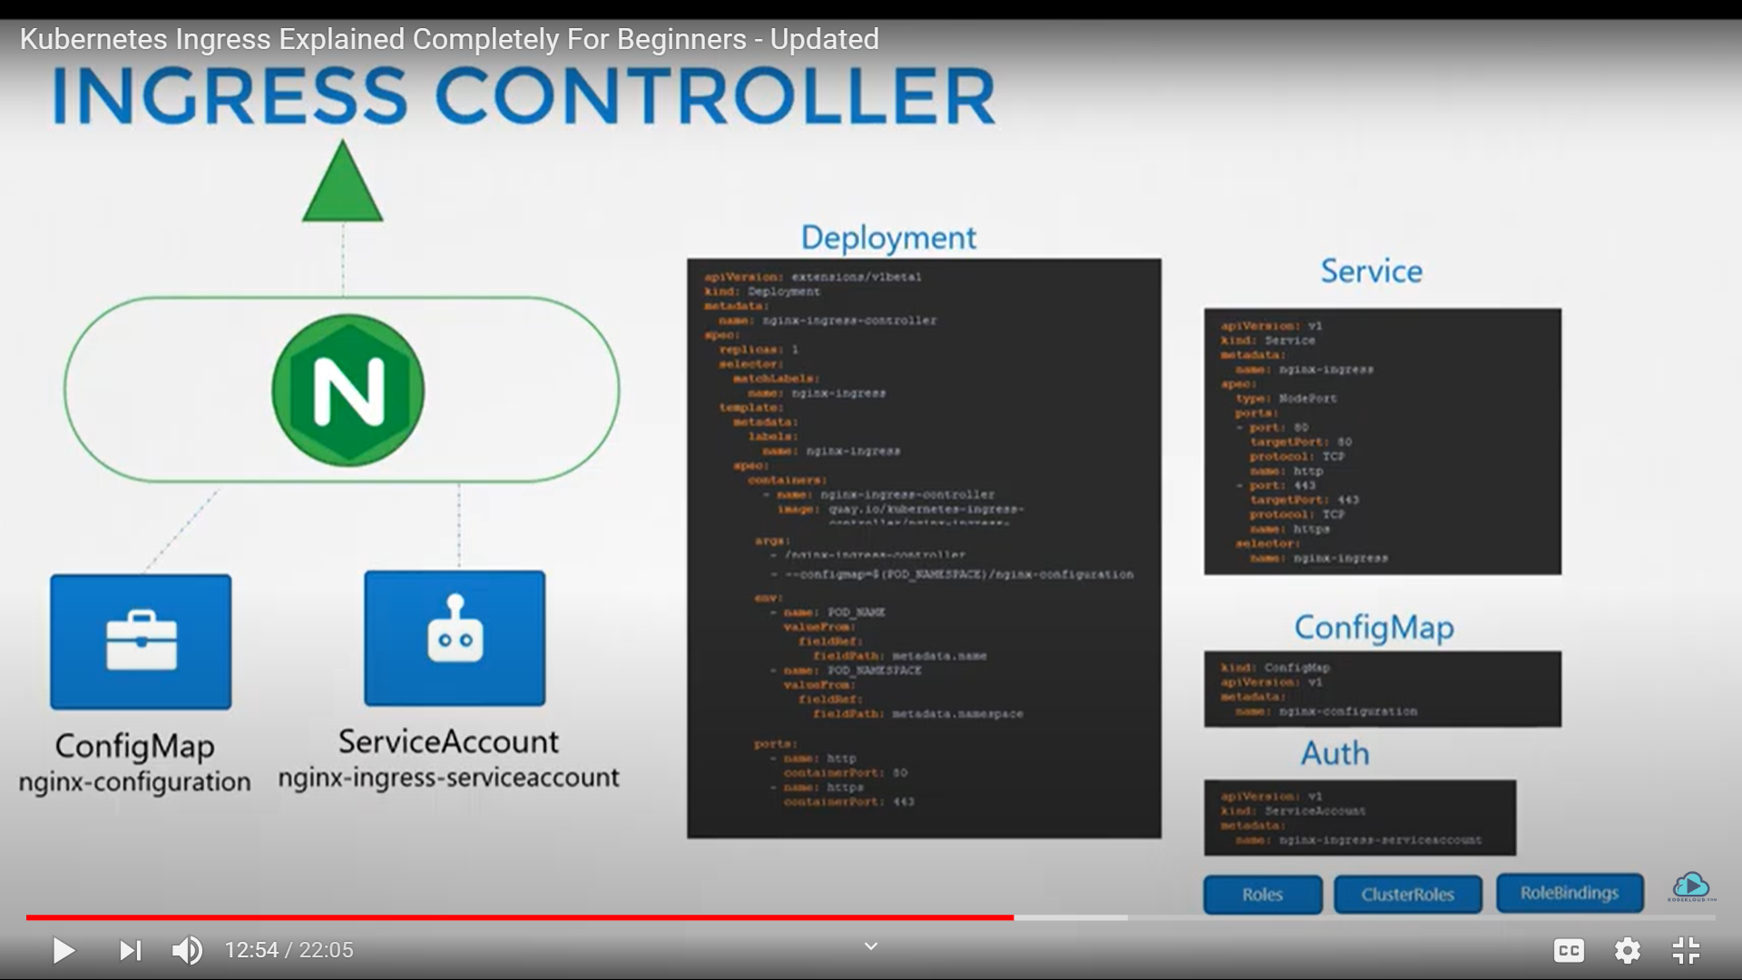

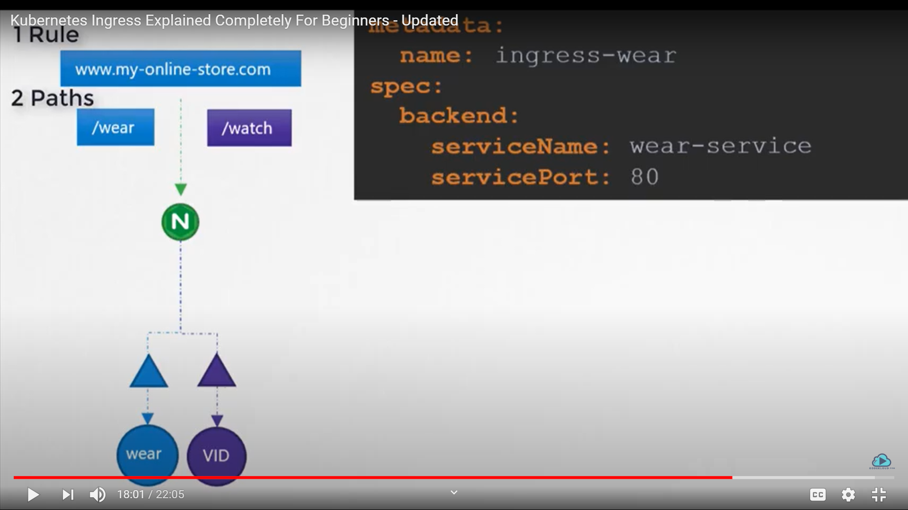

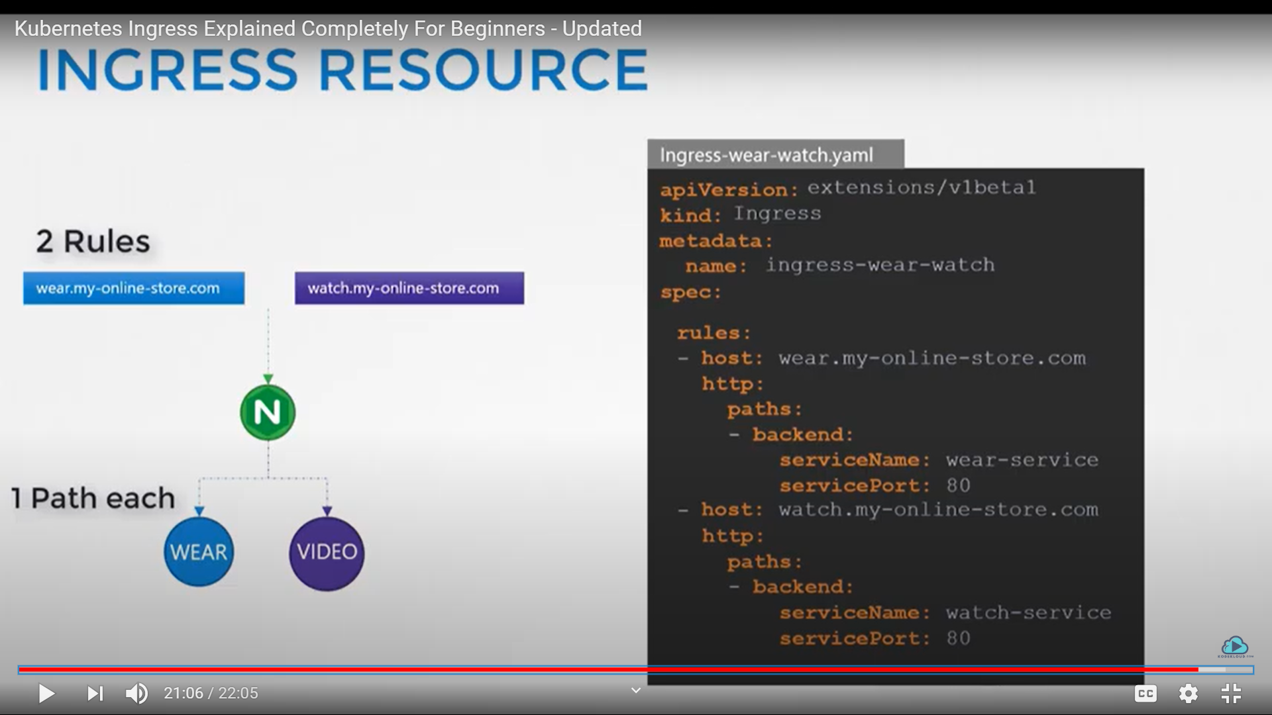

Different ingress controllers have different options that can be used to customise the way it works. NGINX Ingress controller has many options that can be seen [here](https://kubernetes.github.io/ingress-nginx/examples/). I would like to explain one such option that we will use in our labs. The [Rewrite](https://kubernetes.github.io/ingress-nginx/examples/rewrite/) target option.

Our watch app displays the video streaming webpage at http://<watch-service>:<port>/

Our wear app displays the apparel webpage at http://<wear-service>:<port>/

We must configure Ingress to achieve the below. When user visits the URL on the left, his request should be forwarded internally to the URL on the right. Note that the /watch and /wear URL path are what we configure on the ingress controller so we can forwarded users to the appropriate application in the backend. The applications don't have this URL/Path configured on them:  
  
http://<ingress-service>:<ingress-port>/watch --> http://<watch-service>:<port>/

http://<ingress-service>:<ingress-port>/wear --> http://<wear-service>:<port>/

Without the rewrite-target option, this is what would happen:

http://<ingress-service>:<ingress-port>/watch --> http://<watch-service>:<port>/watch

http://<ingress-service>:<ingress-port>/wear --> http://<wear-service>:<port>/wear

Notice watch and wear at the end of the target URLs. The target applications are not configured with /watch or /wear paths. They are different applications built specifically for their purpose, so they don't expect /watch or /wear in the URLs. And as such the requests would fail and throw a 404 not found error.

To fix that we want to "ReWrite" the URL when the request is passed on to the watch or wear applications. We don't want to pass in the same path that user typed in. So we specify the rewrite-target option. This rewrites the URL by replacing whatever is under rules->http->paths->path which happens to be /pay in this case with the value in rewrite-target. This works just like a search and replace function.

For example: replace(path, rewrite-target)  
In our case: replace("/path","/")

1. apiVersion: extensions/v1beta1
2. kind: Ingress
3. metadata:
4. name: test-ingress
5. namespace: critical-space
6. annotations:
7. nginx.ingress.kubernetes.io/rewrite-target: /
8. spec:
9. rules:
10. - http:
11. paths:
12. - path: /pay
13. backend:
14. serviceName: pay-service
15. servicePort: 8282

In another example given [here](https://kubernetes.github.io/ingress-nginx/examples/rewrite/), this could also be:

replace("/something(/|$)(.*)", "/$2")

1. apiVersion: extensions/v1beta1
2. kind: Ingress
3. metadata:
4. annotations:
5. nginx.ingress.kubernetes.io/rewrite-target: /$2
6. name: rewrite
7. namespace: default
8. spec:
9. rules:
10. - host: rewrite.bar.com
11. http:
12. paths:
13. - backend:
14. serviceName: http-svc
15. servicePort: 80
16. path: /something(/|$)(.*)

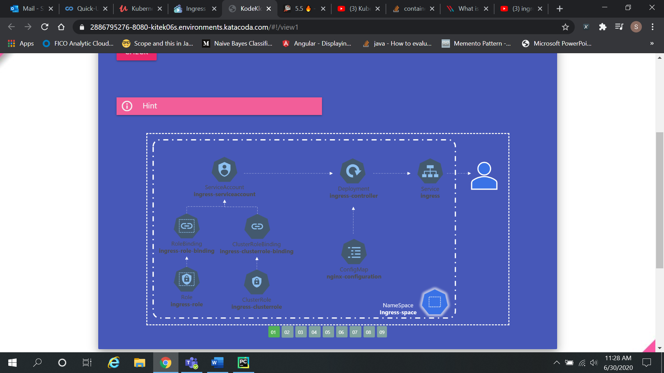

Services help in making sure microservices are coupled loosely.

NodePort Service - There are three main components. The port refers to the port on the service. The targetPort is the port on the POD. The nodePort is the port exposed by the Node.

Also add the selector to the definition file for the service to address the POD. We can access the POD using http://<nodeIP>:<portNumber>.

Cluster IP – We specify the selector, which is the POD the request is forwarded to, the port on the service and the target Port, i.e. the POD.

Ingress Networking – We create a service (Ingress) which is used as the interface between the

Deployment (Ingress Controller) and the user. The Ingress Controller is injected with a ConfigMap and a ServiceAccount which specifies the Roles and Bindings. All of this is found in the

namespace (ingress-space).

LoadBalancer – We create a LoadBalancer, which performs the functions of the NodePort and in addition can be used to set the rules and paths correctly. In the example of <http://example.com>, if we have <http://example.com/path1> and <http://example.com/path2>, this can be set easily via the

Rules and Paths concept.

* Network Policy

Consider three components. A web server serving front end, an app server serving back end

APIs and the Database server. User sends a request to the web server at port 80, the web server sends a request to the API server on port 5000, and the API server then fetches data from the

DB server at port 3306 and sends the data back to the user.

User 🡪 Web Server (80) 🡪 API Server (5000) 🡪 DB Server (3306)

User 🡨 Web Server (80) 🡨 API Server (5000) 🡨 DB Server (3306)

Incoming traffic from the user is called Ingress Traffic, i.e. User 🡪 Web Server and the outgoing

traffic to the Web server is Egress Traffic, i.e. Web Server 🡪 API Server.

Ingress and Egress mainly address the origination of traffic.

With respect to the API Server, it receives Ingress Traffic from the Web Server and has Egress

Traffic to the DB server.

In the context of K8s, we deploy a POD for each of the servers. We then create services to

enable communication between the PODs and with the end user. Suppose we do not want the Web server to be able to directly access the DB server and all web traffic needs to be routed to

the API server. Here, we would implement a Network Policy.

A network policy is another object in the K8s namespace. We link a N/w Policy to a POD.

In our case, we can set a N/w policy on the DB server to only allow Ingress Traffic from the

API server.

First, we use labels and matchLabels to identify the POD.

**labels**:

**role**: db

**podSelector**:

**matchLabels**:

**role**: db

The file definition is as follows –

**apiVersion**: networking.k8s.io/v1

**kind**: NetworkPolicy

**metadata**:

**name**: db-policy

**spec**:

**podSelector**:

**matchLabels**:

**role**: db

**policyTypes**:

- Ingress

**ingress**:

**- from**:

**- podSelector**:

**matchLabels**:

**name**: api-pod

**ports**:

**- protocol**: TCP

**port**: 3306

The syntax for Egress is as follows –

**apiVersion**: networking.k8s.io/v1

**kind**: NetworkPolicy

**metadata**:

**name**: internal-policy

**spec**:

**podSelector**:

**matchLabels**:

**name**: internal

**policyTypes**:

- Egress

- Ingress

**ingress**:

- {}

**egress**:

**- to**:

**- podSelector**:

**matchLabels**:

**name**: mysql

**ports**:

**- protocol**: TCP

**port**: 3306

**- to**:

**- podSelector**:

**matchLabels**:

**name**: payroll

**ports**:

**- protocol**: TCP

**port**: 8080

* Volumes

Docker containers are meant to last a short time. This means that any data processed by them is destroyed is also destroyed when the containers are destroyed. Instead, we can attach a volume to the container and make sure the data is stored there so that we have access to it permanently.

In K8s, PODs are transient in nature. Therefore, the data generated by the POD is now stored in the volume.

Let us say we create a simple POD which generates a random number between 1-100 and outputs it to a file.

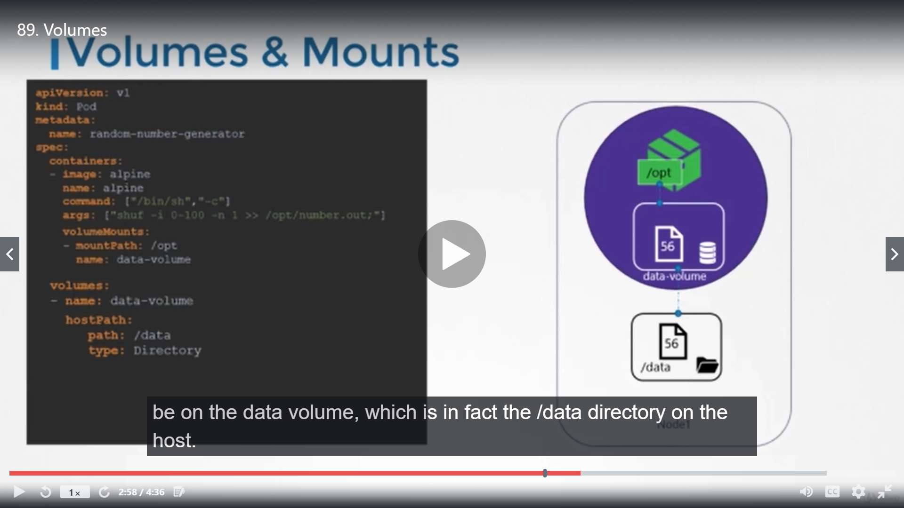

**apiVersion**: v1

**kind**: Pod

**metadata**:

**name**: random-number-generator

**spec**:

**containers**:

**- image**: alpine

**name**: alpine

**command**: ["/bin/sh", "-c"]

**args**: ["shuf -i 0-100 -n 1 >> /opt/number.out;"]

**volumeMounts**:

**- mountPath**: /opt

**name**: data-volume

**volumes**:

**- name**: data-volume

**hostPath**:

**path**: /data

# type: Directory

# awsElasticBlockStore:

# volumeID: <volume-id>

# fsType: ext4

* Persistent Volumes

A persistent volume is a cluster wide pool of storage volumes configured by an administrator to be used by users deploying applications on the cluster. The users can now select storage from this pool using Persistent Volume Claims.

pv-definition.yml

**apiVersion**: v1

**kind**: PersistentVolume

**metadata**:

**name**: pv-vol1

**spec**:

**accessModes**:

- ReadWriteOnce # ReadOnlyMany, ReadWriteMany are the other options

**capacity**:

**storage**: 1Gi

**hostPath**:

**path**: /tmp/data

* Persistent Volume Claims

Persistent Volume and PVC are two separate objects in the K8s namespace. The administrator creates a set of PVs and the user creates PVCs to use the storage. Once the PVCs are created, K8s binds the PVs to the PVCs based on the request and properties set on the volume. Every PVC is bound to a single PV based on properties like Capacity, Access Mode, Volume Mode and Storage Class.

If we wish to use a particular PV, we can use labels to bind the PVC to that PV. If no PV exists for a PVC, then the PVC remains in the pending state until another PV is assigned to it.

Pvclaim-definition.yml

**apiVersion**: v1

**kind**: PersistentVolumeClaim

**metadata**:

**name**: myclaim

**spec**:

**accessModes**:

- ReadWriteOnce # ReadOnlyMany, ReadWriteMany are the other options

**resources**:

**requests**:

**storage**: 500Mi

volumeName: "pv-vol1"

Once we delete the claim, the persistentVolumeReclaimStrategy can be set to Retain or Delete, the former meaning that the PV will remain until manually deleted and the latter meaning that once the PVC is deleted, the PV is deleted along with it. The other option is Recycle, where the data is erased before assigning to some other PVC.

Once you create a PVC use it in a POD definition file by specifying the PVC Claim name under persistentVolumeClaim section in the volumes section like this:

1. apiVersion: v1
2. kind: Pod
3. metadata:
4. name: mypod
5. spec:
6. containers:
7. - name: myfrontend
8. image: nginx
9. volumeMounts:
10. - mountPath: "/var/www/html"
11. name: mypd
12. volumes:
13. - name: mypd
14. persistentVolumeClaim:
15. claimName: myclaim

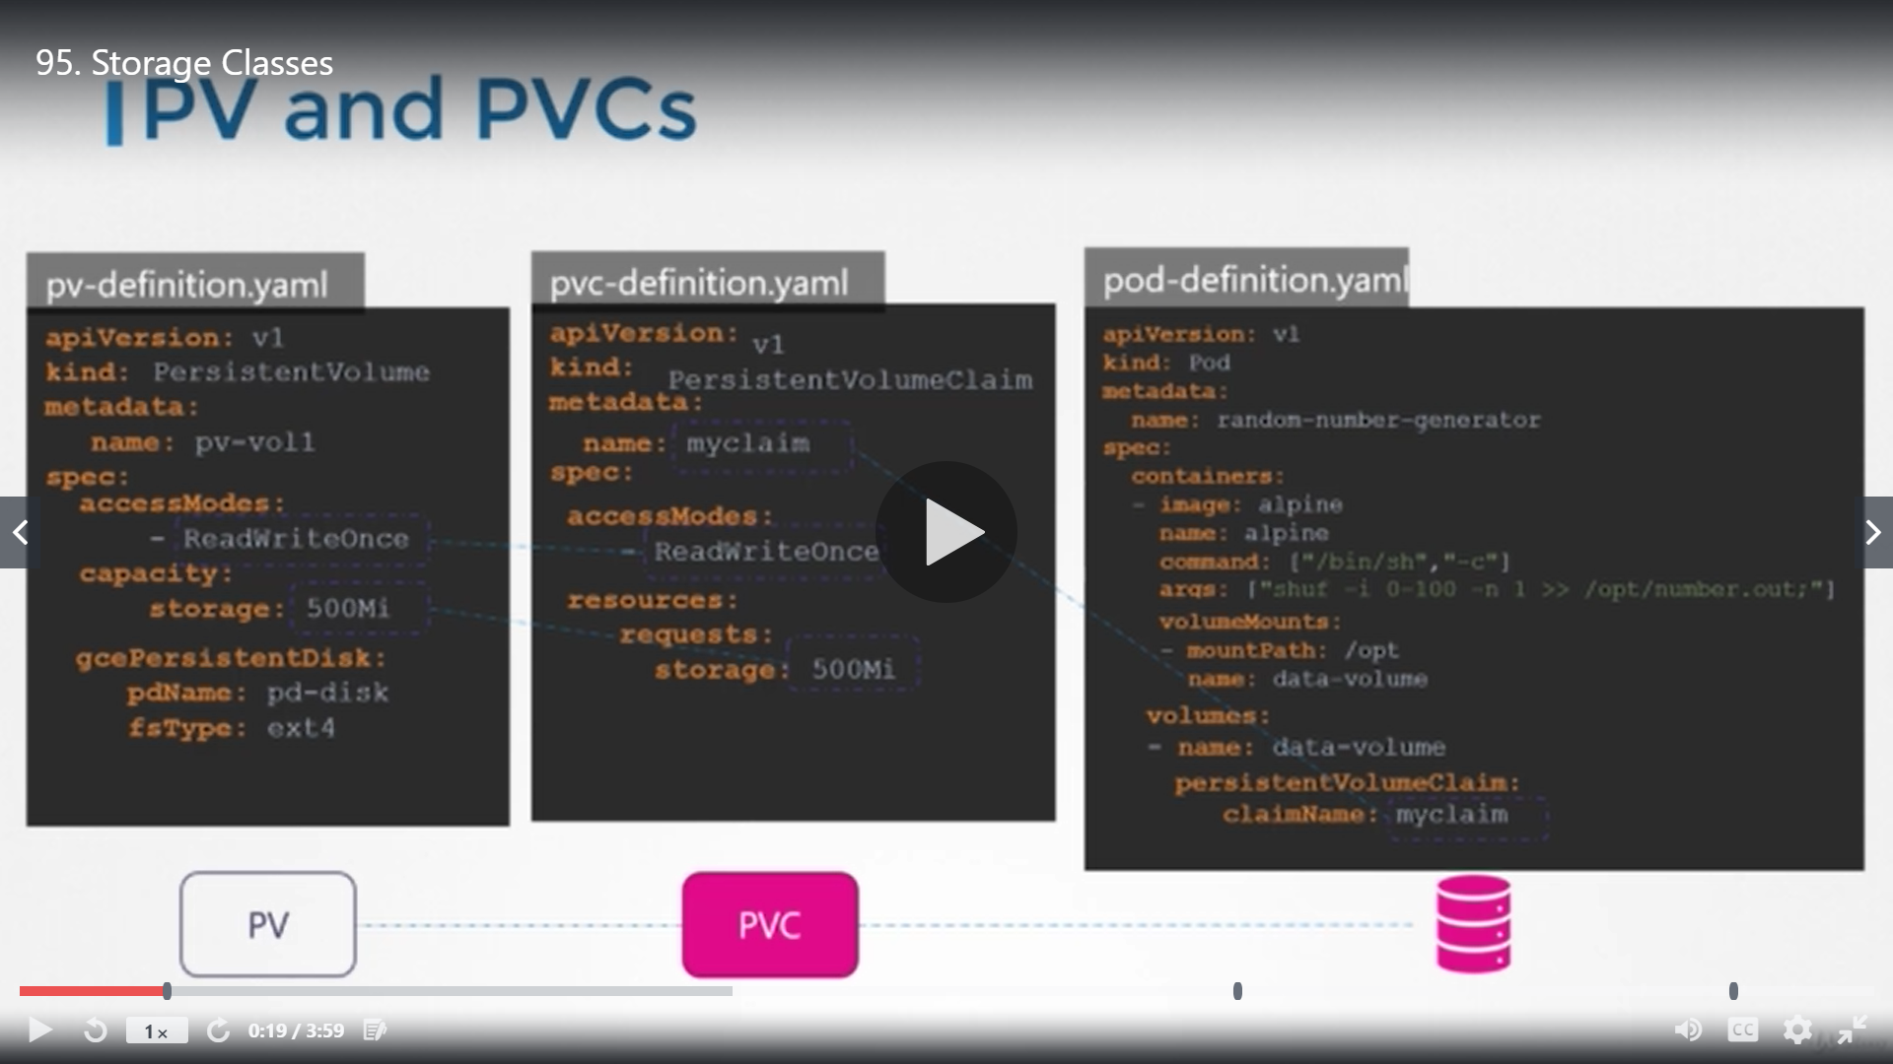

The same is true for ReplicaSets or Deployments. Add this to the pod template section of a Deployment on ReplicaSet.

**Host path:** The directory in your node.  
**Mount path:** The directory in your pod.

* Storage Classes

Static provisioning volumes – We basically create the storage beforehand in a platform Google cloud disk.

Gcloud beta compute disks create \ -- size 1GB –region us-east1 pd-disk

Dynamic Provisioning is done via storage classes.

StorageClass-definition.yml

**apiVersion**: storage.k8s.io/v1

**kind**: StorageClass

**metadata**:

**name**: google-storage

**provisioner**: kubernetes.io/gce-pd

**parameters**:

**type**: pd-standard # pd-ssd

**replication-type**: none # regional-pd

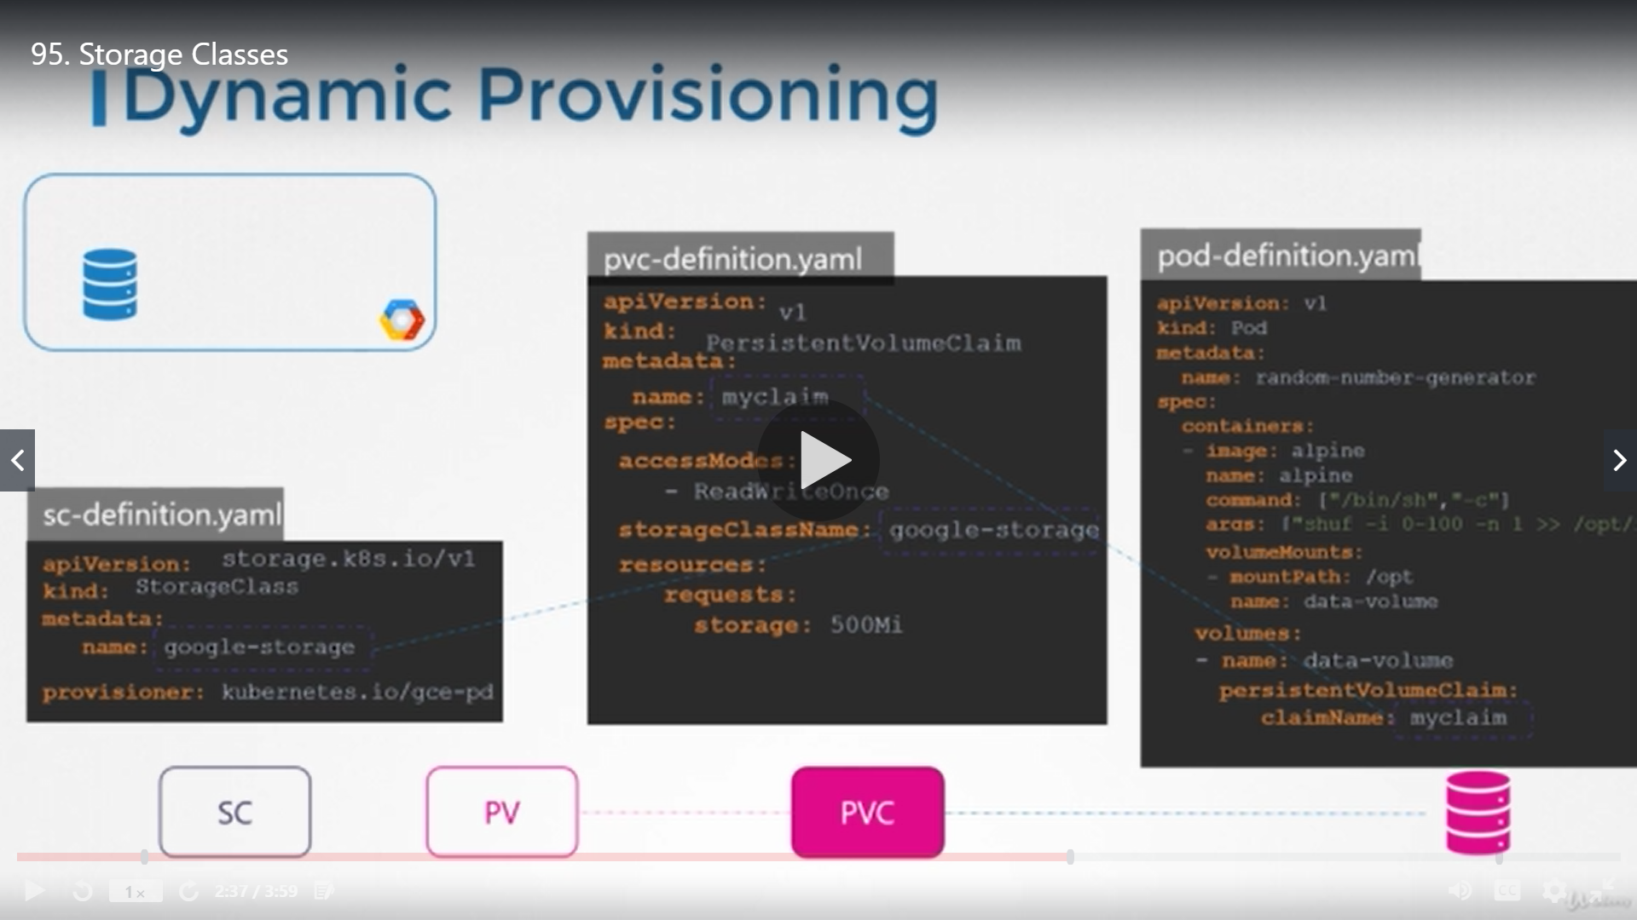

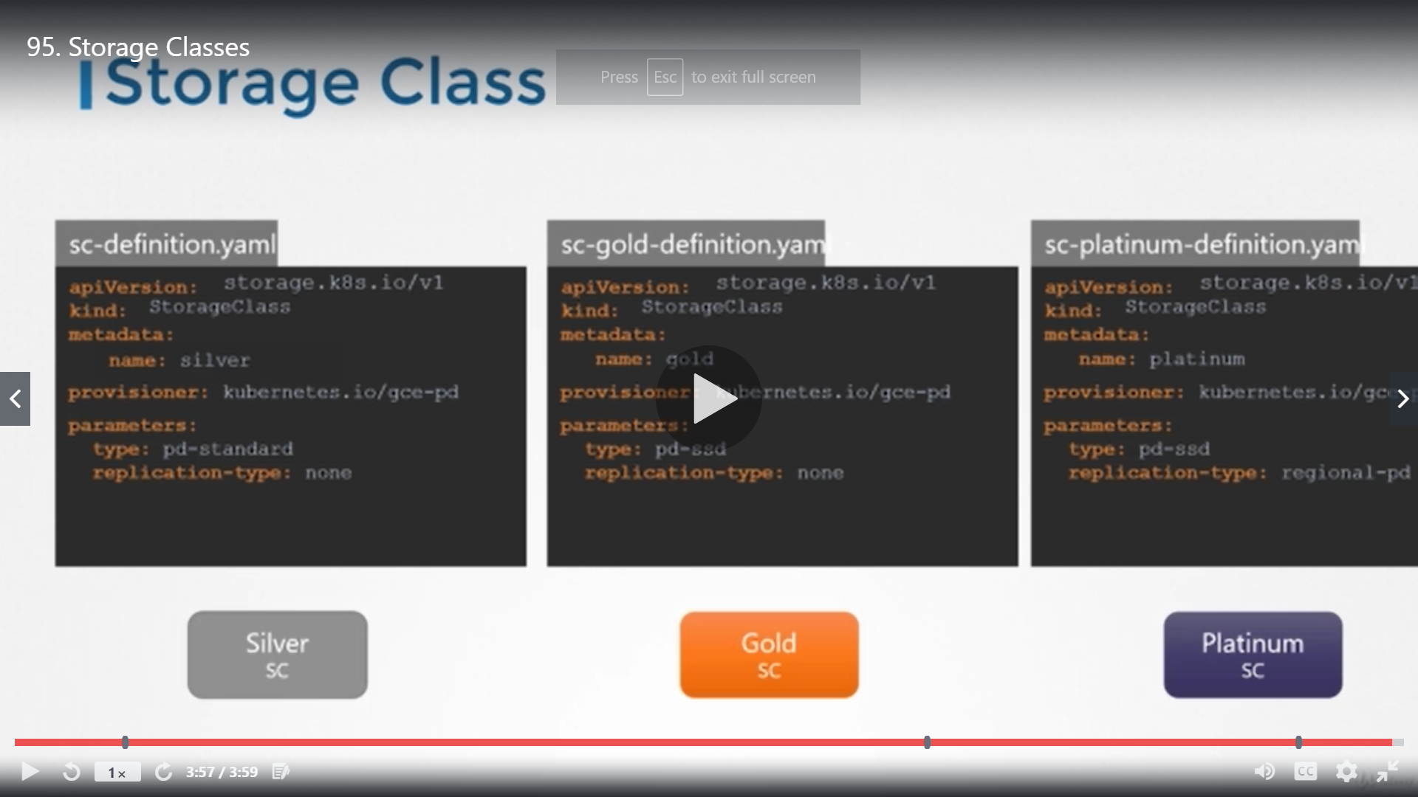

* Stateful Sets

Stateful Sets are like deployments, however there are a few differences. In stateful sets, PODs are created in a sequential order. The POD must be in a ready and running state before the next POD is deployed. Every POD has a unique name/identifier, incremented by 1 for every POD.

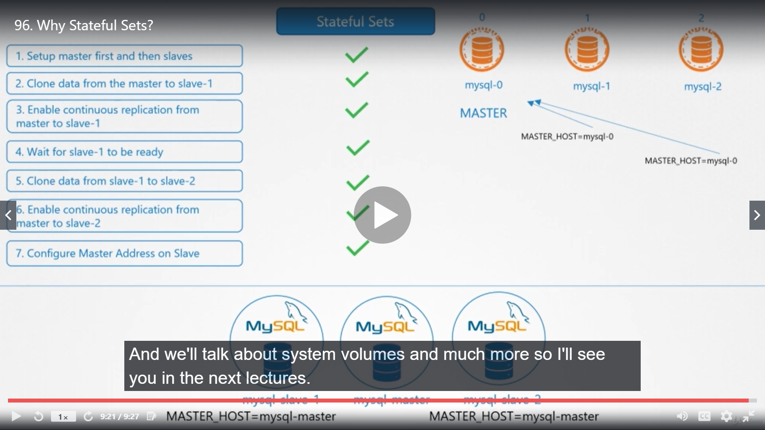

**apiVersion**: apps/v1

**kind**: StatefulSet

**metadata**:

**name**: mysql

**spec**:

**template**:

**metadata**:

**labels**:

**app**: mysql

**spec**:

**containers**:

**- name**: mysql

**image**: mysql

**replicas**: 3

**selector**:

**matchLabels**:

**app**: mysql

**serviceName**: mysql-h // Headless Service

**podManagementPolicy**: Parallel //Default value is OrderedReady

* Headless Services

A headless service does not have an IP of its own. It does not perform load balancing. It only creates DNS entries for each POD using the POD name and sub domain.

podname.headless-servicename.namespace.svc.cluster-domain.example

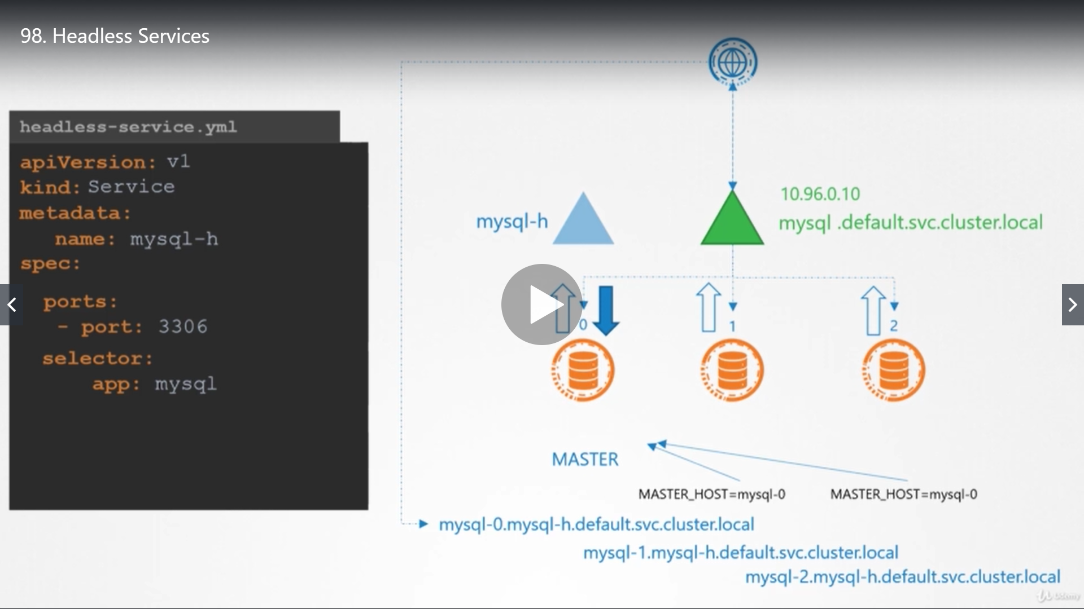

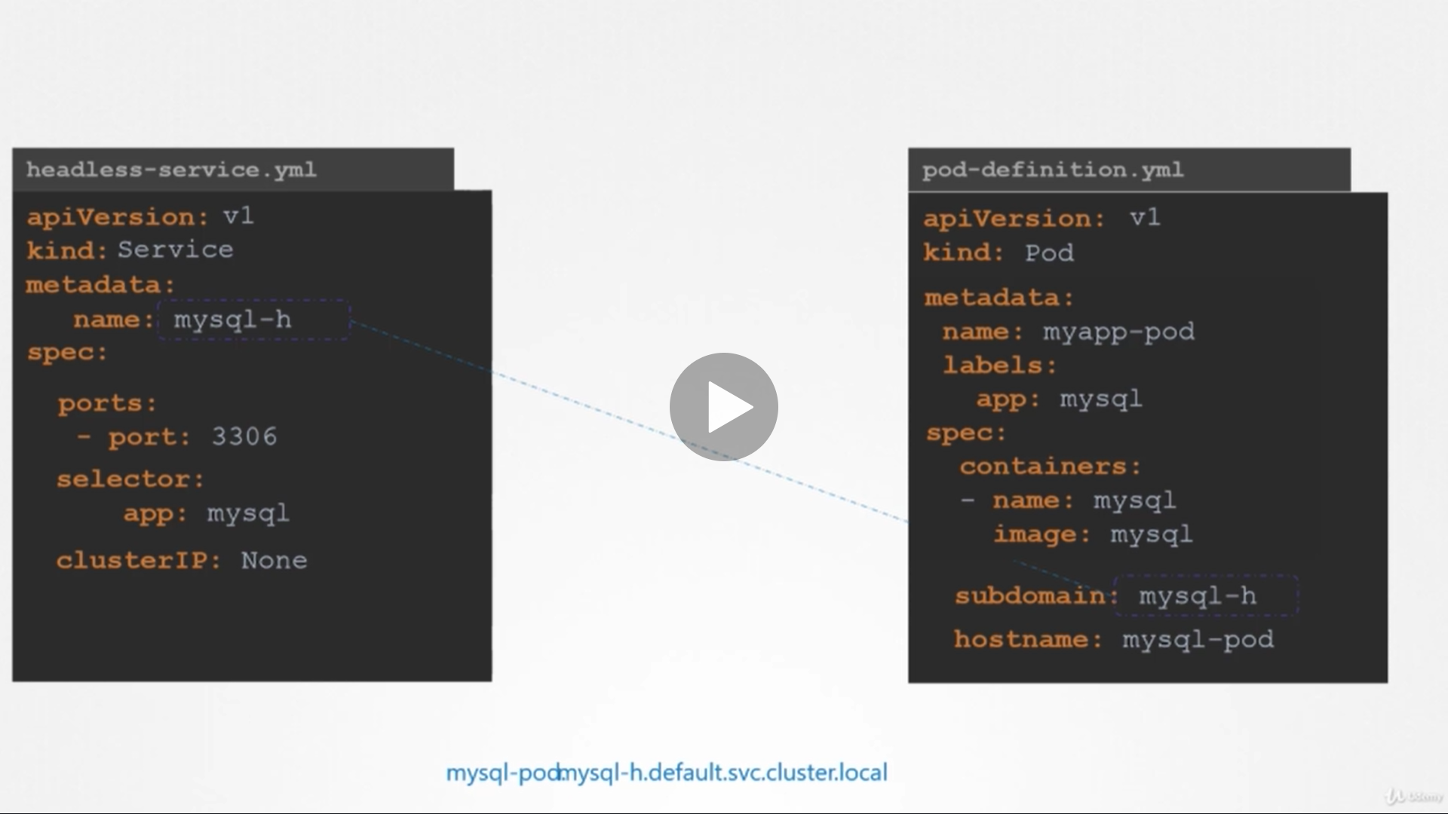

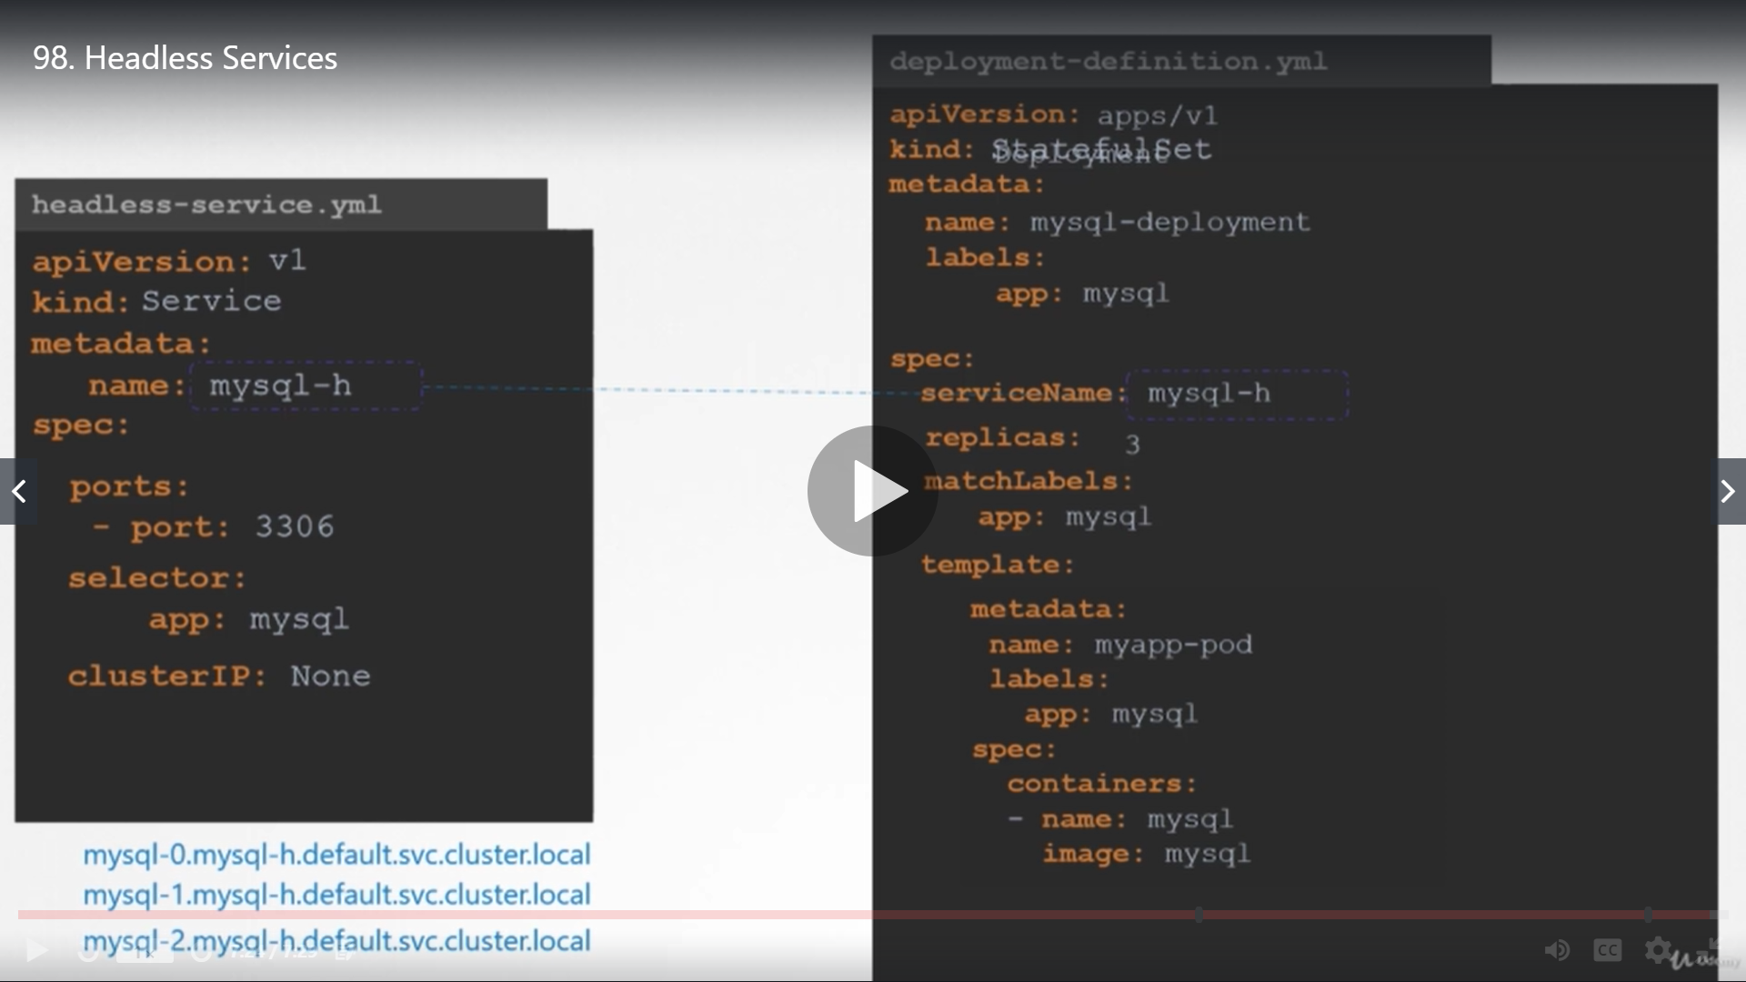

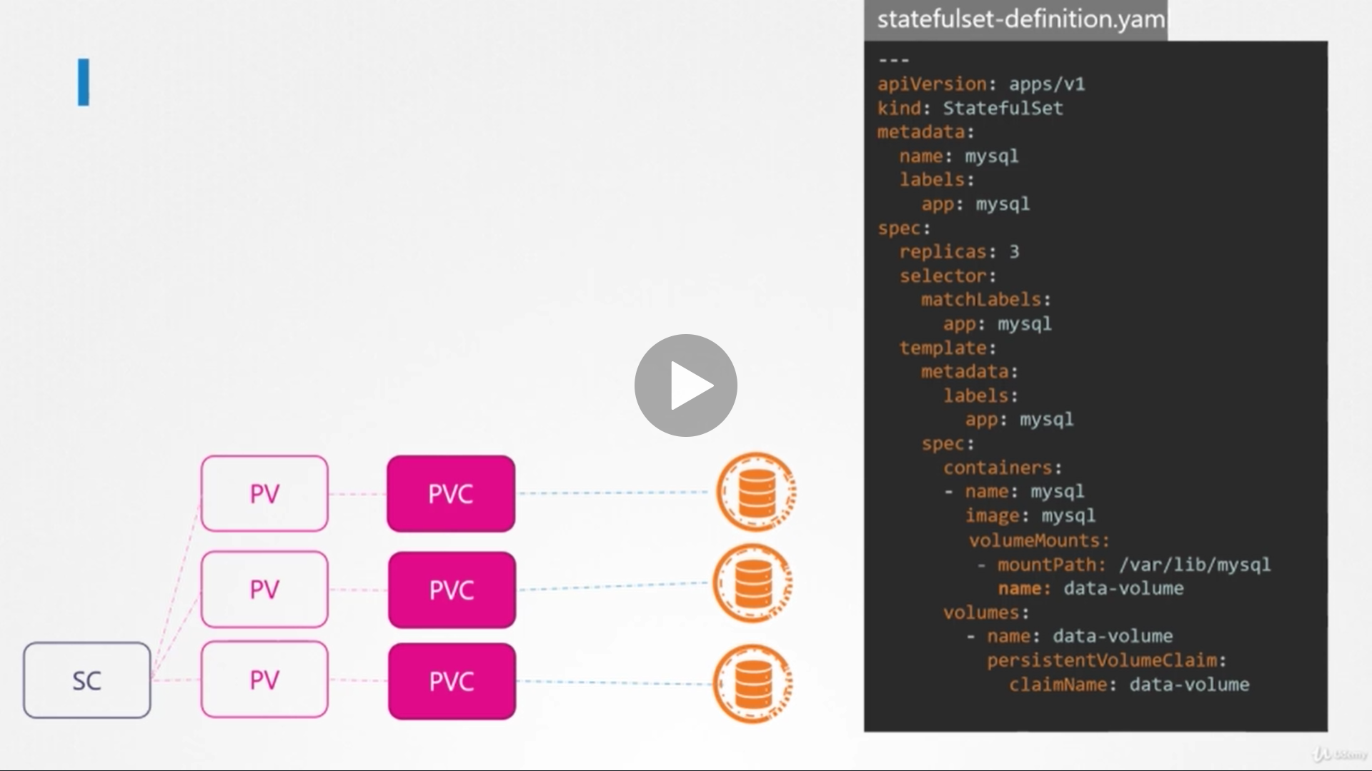

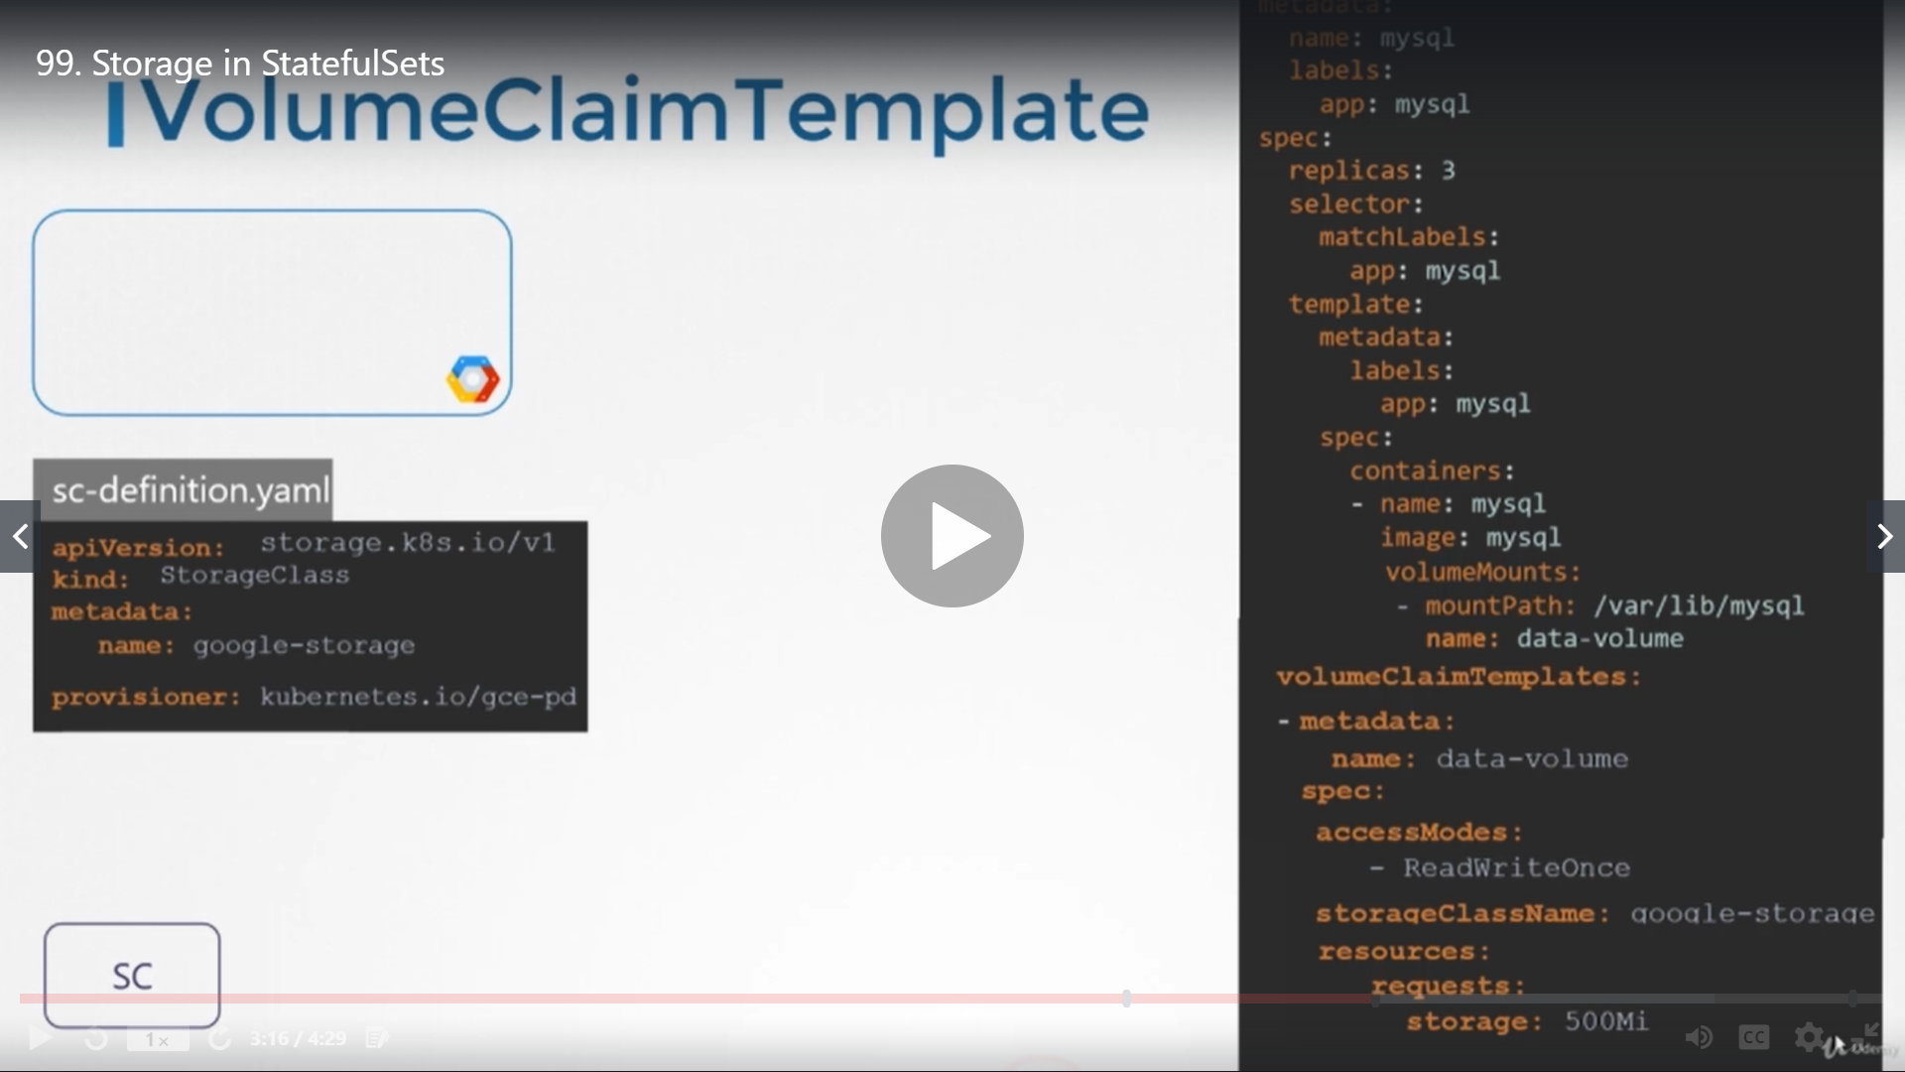

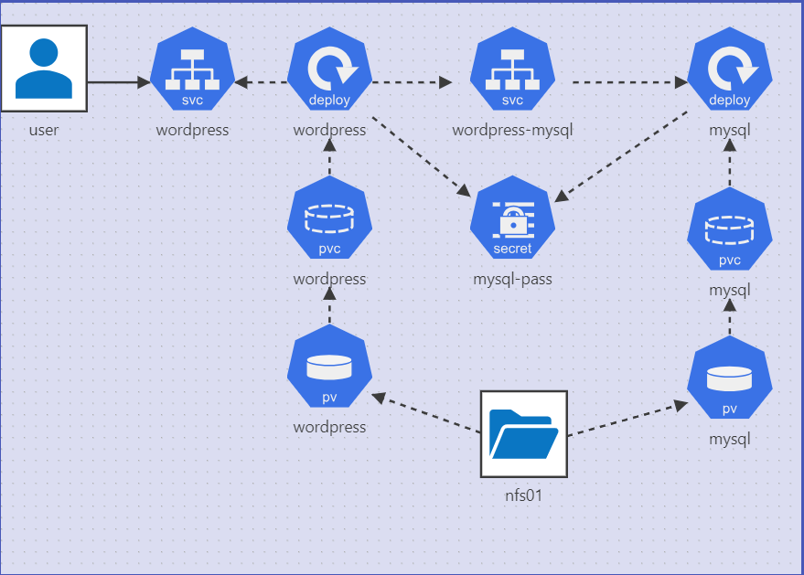

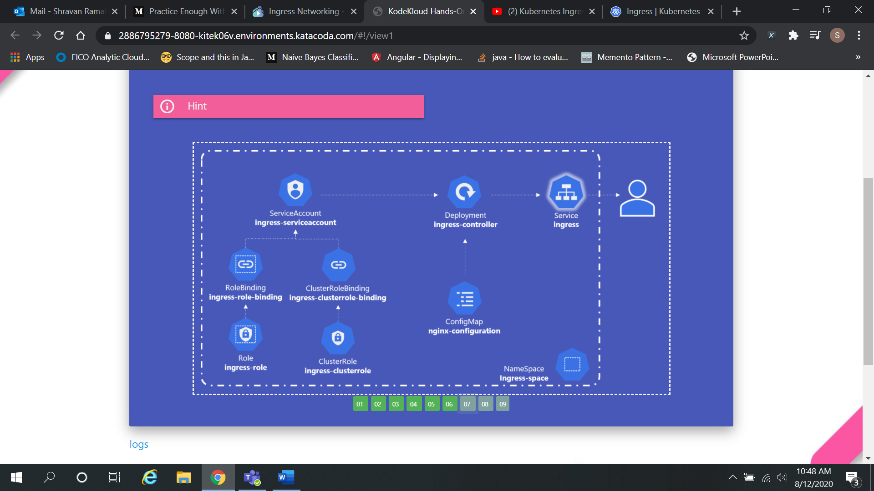

k expose po httpd --type=ClusterIP --port=80 --target-port=80